MEMBERS OF THE COUNCIL YOU ARE HERBY SUMMONED
TO ATTEND AN EXTRAORDINARY MEETING OF
BISHOP'S CASTLE TOWN COUNCIL WHICH WILL BE
HELD IN THE TOWN HALL
ON MONDAY 18th May 2026 AT 7.30 PM

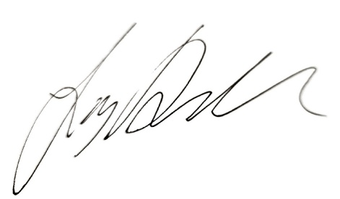

Signed: Josh Dickin

Mayor of

Bishop’s Castle Town Council
A G E N D A

APOLOGIES
To note apologies

DECLARATIONS OF INTEREST
Disclosable Pecuniary Interest
Members are reminded that they must not participate in the discussion or voting on any matter in which they have a Disclosable Pecuniary Interest and should leave the room prior to the commencement of the debate.

a) To declare any disclosable pecuniary interests.
b) To declare any personal interests.

ANNUAL TOWN MEETING
To discuss the concerns raised from the electors at the annual town meeting.

- * | * CONFIDENTIAL MATTERS To resolve that by the Public Bodies (Admission to Meetings) Act 1960 the public and press be excluded for the remainder of the meeting on the grounds the business to be discussed involves the likely disclosure of confidential information as defined in the Acts.
HR ADVICE
To discuss and decide on the recruitment of advisor(s) to the Council.

