MEMBERS OF THE COUNCIL YOU ARE HERBY SUMMONED
TO ATTEND AN EXTRAORDINARY MEETING OF
BISHOP'S CASTLE TOWN COUNCIL WHICH WILL BE
HELD IN THE TOWN HALL
ON Thursday 31st July AT 7.30 PM

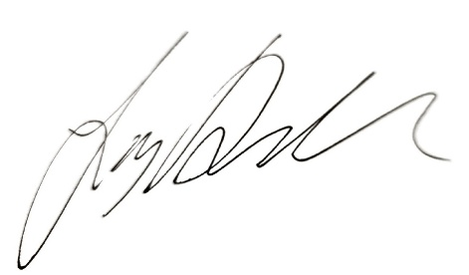

Signed: Josh Dickin

Mayor of Bishop’s Castle Town Council
A G E N D A

APOLOGIES
To note apologies

DECLARATIONS OF INTEREST
Disclosable Pecuniary Interest
Members are reminded that they must not participate in the discussion or voting on any matter in which they have a Disclosable Pecuniary Interest and should leave the room prior to the commencement of the debate.

a) To declare any disclosable pecuniary interests.
b) To declare any personal interests.

PUBLIC CONVENIENCE
To decide whether to apply for a PWLB (Public Works Loan to the PWL board) to refurbish the Public Conveniences in the Auction Yard to the value of £75k.

NEWSLETTER
To discuss and decide that enterprise house takeover the production and distribution of the newsletter.
HR SUPPOORT
To discuss and decide on appointing a HR advisor

