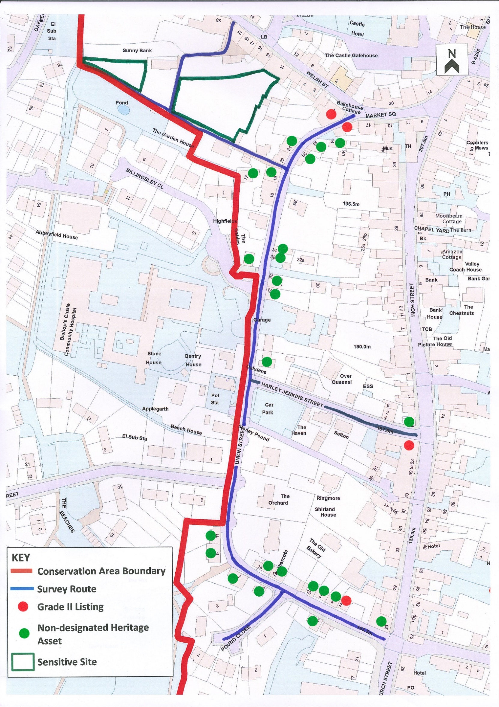
ZONE 7 SURVEY ASSESSMENT – Union Street, Harley Jenkins Street, Pound Close and Laburnum Alley

Character Assessment Route and Description | Value Range  very negative to very positive
ZONE 7. Union St./Harley Jenkins St/Pound Close/ Laburnum Alley
DATE: 13 & 15 August 2019 TIME: 11 am-3 pm WEATHER: Dry & sunny
- VIEW (i) of UNION ST. from Church St. towards the playing fields entrance  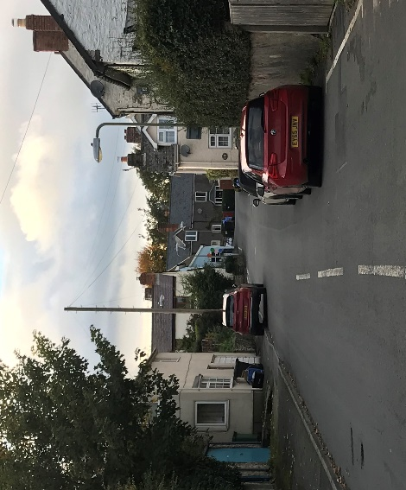  This section of Union Street, formerly known as Pigfair, curves very slightly to the right and inclines upwards slightly. It provides a long view up to the point at which the street turns sharply to the right. The focal point is No. 9 (Pound House) at the end of the view. Although traffic is parked on the side elevation of Burd’s shop on the north side of the carriageway, it does not obstruct the view.  The entrance to Pound Close on the south side is clearly visible, but the access to the playing fields by Pound House can barely be seen. Two houses on the south side are in view. On the north edge of the carriageway hedging in the foreground obscures the first three houses. No. 10 which is built at right angles to the road can be seen clearly but it blocks the view of the two houses beyond. Overhead, telephone wires impinge on the view.  The view west from Church St, just beyond Burd’s shop  One part of the side of Burd’s shop is three stories high; all other buildings in this zone are of two stories. The absence of tall buildings, the visible gaps and the long view with an extensive sky-scape give an open feel. The road is at its widest near the junction with Church Street where there is a short stretch of pavement on the southern edge of the carriageway. This is the only pavement in the street and it ends at the entrance to Pound Close. The road gradually narrows along its length.  Reverse view:  Looking downhill from the playing fields entrance by Pound House to the Church Street junction, the dominant view in the foreground is the Boar’s Head on Church Street, with Station Street to its left. Further beyond the view is dominated by a ‘big sky’ with lovely distant views over Oakley Mynd on the horizon. The feeling is open, despite the fact that the southern side of the lower part of the street was in shade. | VN |  | N |  | 0 |  | P | VP
 |  |  | X |  | X |  | X  X
- COMPONENTS of the STREETSCAPE from Church St. towards the playing fields entrance  At the end nearest to Church Street the hard surfaces of the long stretch of road ahead and the side elevation of Burd’s are offset by a hedge atop a rendered stone wall beyond Burd’s and on the opposite, south side of the carriageway by dense planting in the garden of No. 21 Church Street.  There is no dominant feature save for the view directly ahead of No. 9 (Pound House) which presents a sombre appearance in comparison with surrounding  houses due to its unpainted rendered wall finish. The majority of buildings in this section of the street are either dwellings, probably of 18th and 19th century origin, or garages. Burd’s is the only commercial premises. Although its main entrance is on Church Street, it has a significant side elevation of both two and three stories on Union Street. The three-story elevation has a door, but with no external access, at first floor level.  Most houses on the street are rendered. This has probably been used to provide added protection to buildings which are either timber framed or where the stone surface was unstable. The exceptions are No. 7 (painted brick), No. 8 (stone) and No. 14 (unpainted brick). Roofs display a variety of materials.  Except for No. 3, along the southern curtilage, narrow paved/landscaped areas in front, or to the side of all houses in this zone enhance the appearance of these buildings and, in part, set them back very slightly from the edge of the road.  Two buildings have a negative impact on the streetscape; No. 4 on the north side; and, directly opposite, No. 3. Both have been insensitively renovated and the latter shows signs of neglect.  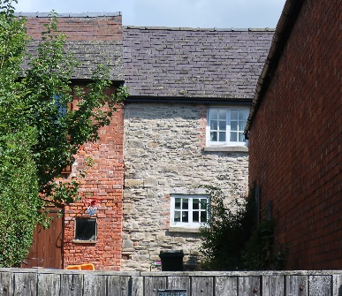  Along the northern side of the street:  Double wooden gates immediately after Burd’s shop lead to an opening that provides an interesting view of old stone and brick buildings to the west. These adjoin and are to the rear of No. 25 Church Street.  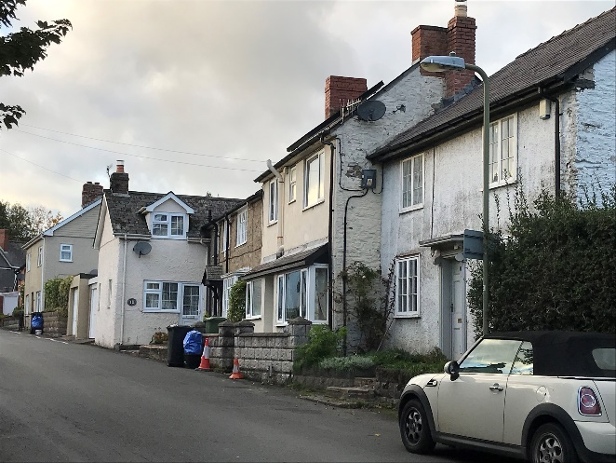  Four adjoining cottages, Nos. 2, 4, 8 and 10 sit in the middle section of the street abutting the northern edge of the carriageway. They display different and an interesting variety of styles, roofs and staggered frontages and one is built at right angles to the others.  With the exception of No. 4, these are pleasing to the eye. No. 2 which is set slightly further back than the rest is the most attractive of this group and is classified as a Grade II Listed building. The other three cottages are classified as non-designated heritage assets.  The absence of a No. 6 would suggest that No. 8 or, more likely, No. 4 were once two dwellings.  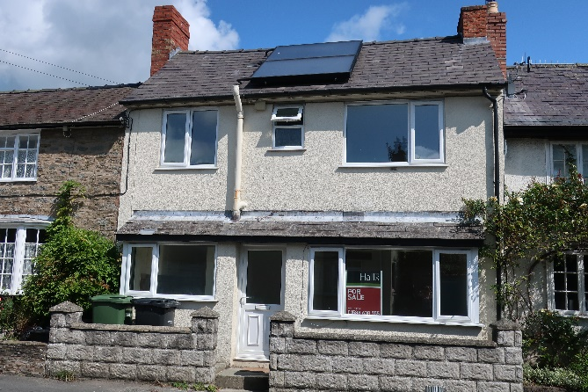  No. 4, like the two adjoining cottages on its western side has been renovated. Unlike its neighbours however the external renovations appear inappropriate. They include a concrete block wall along the frontage and, more recently, solar panels and disproportionately large uPVC windows.  Number 4 Union Street  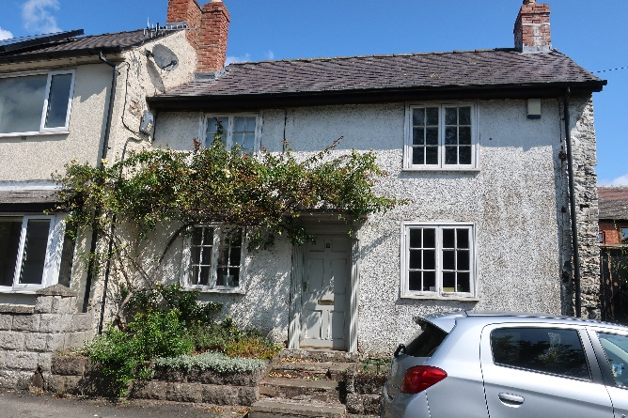  The façade conflicts particularly with the Grade II Listed cottage that adjoins it on its eastern side. Perhaps unsurprisingly given its listing No. 2 is the most attractive of the group of four houses in which it sits.  Number 2 Union Street  Two modern flat-roofed garages at the western end of the cottage row do not have an appearance sympathetic with the properties they serve.  Beyond the four adjoining cottages, Nos. 12 and 14 adjoin, with 14 being stepped back slightly. These are of different styles with broken rooflines.  No. 14 is sited at the corner of Union Street where the road turns sharply to the north. It has a single-story extension behind which can be seen a modern bungalow - Nethercott. At this point the significant difference in ground levels is evident, with Nethercott being at the level of the roof of No. 14.  Along the southern side of the street:  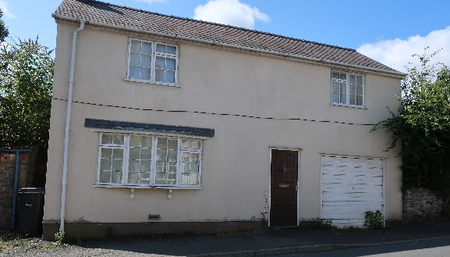  The densely planted garden of No. 21 Church Street gives way to an old stone store and garage with a corrugated asbestos roof. No. 3 is rendered and has an integral garage. This house is of indeterminate age when viewed externally due to insensitive modern alterations. It is however classified as a non-designated heritage asset. A raised area of garden which is rather overgrown contrasts pleasingly with the built environment. The entrance to Pound Close provides a view of the first section of this road which rises steeply to the south.  No. 5 Union Street is at right angles to the road. It has an offshoot to the rear with an adjoining garage that is in keeping with the house itself. These are both on the main axis of Union Street.  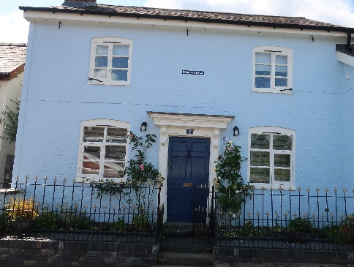  Pound Cottage (No. 7), another non-designated heritage asset, has recently been restored to a high and sympathetic standard. The windows and door are of a simple, restful appearance. The walls are painted in a bright, but not abrasive, colour.  At the side of the driveway to Pound Cottage a tarmac path leads to the playing fields. The path culminates in a modern archway, decorated in mosaics, and  topped with a beetle. Through the archway can be glimpsed a flower border, which is tended by keen local gardeners, and, further beyond, trees on the far side of the playing fields. | VN |  | N |  | 0 |  | P | VP
 | VN  X  VN  X  X  X  VN |  | X  N  N  N |  | 0  X  X  0  X  X  0 |  | X  P  X  X  X  P  X  X  X  X  P | VP  VP  VP  X  X
C. DETAILED DESCRIPTION of SIGNIFICANT ELEMENTS of the streetscape from Church St. towards the playing fields entrance  This section of Union Street has a pleasing appearance and feel. The mix of styles of houses does not present a jarring appearance and, with the exception of the view of Pound Close from its junction with Union Street, there is a sense of continuity. Of the 12 properties in the street, No. 2 is a Grade II Listed building and the other 11 are all classified as non-designated heritage assets albeit that for 2 of them unsympathetic renovations belie their heritage status.  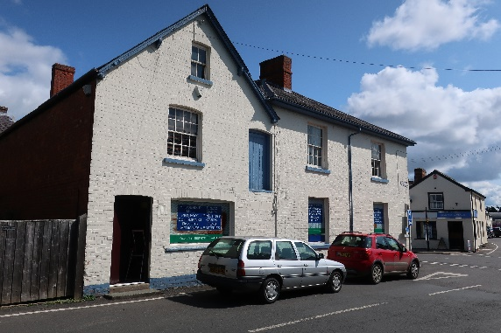  To the side elevation of Burd’s shop three ground floor windows are obscured by interesting signage advertising the wide range of products for sale. These include ‘cigarettes’ and ‘film’. The building, which has an address of 23 Church Street, was briefly (c.1864-1868) The Railway Tavern, one of 46 pubs that have operated in the town since the 1600s and which are now included in the Lost Pubs Trail, an historic guide which is referenced by a plaque on the wall of each premises.  The names of the buildings and streets towards the top of this section (Pound House, Pound Cottage, Pound Forge and Pound Close) also reference the town’s historic nature being evidence of the existence of a pound in this area.  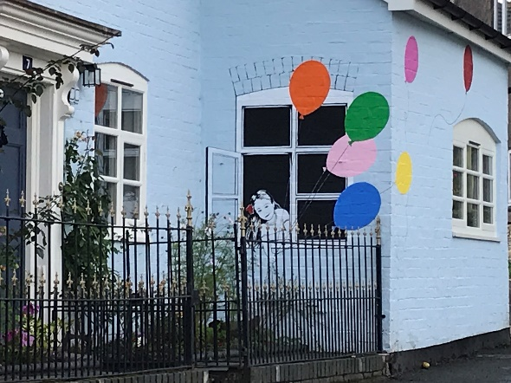  Arguably the most prominent and attractive building in this locality is Pound Cottage (No. 7) with its striking blue paint and decorative mural, one of several properties in the town which have an artistic treatment that reflects something in the character of the property and/or the town. Here, the blank wall of the projecting frontage reveals a young girl leaning out of a window.  Pound Cottage can be seen from several elevated areas in the town including the Castle Hotel gardens.  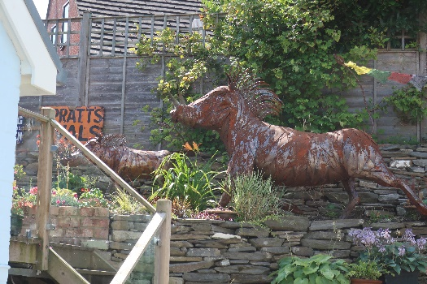  In its rear garden, and visible from the street, are two large metal sculptures, the work of local artist the late Roger Williams. As with the murals painted by other artists, his work can also be seen embellishing buildings and gardens throughout the town.  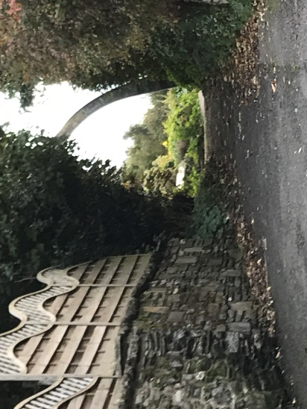  The pathway to the playing fields is reasonably well kept. The mosaic archway and community gardening are evidence of the character and community spirit of the town. This entrance is used heavily throughout the year and particularly on days when annual local events take place in this important amenity space, including the Carnival and the Party in the Park music event.  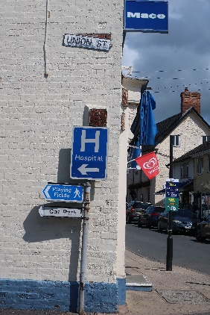  Street signage at the junction with Church Street is useful and informative but not uniform in style and, along with two BT boxes at ground level, presents a somewhat cluttered appearance.  Intrusions in the streetscape were bins at the front of properties where there is no direct access to the rear; insensitive changes to buildings and a building showing signs of neglect.  The only section of pavement is on the south side of the street between Church Street and Pound Close. Where there is no pavement it is necessary for pedestrians to walk on the highway which could be a potential hazard particularly when cars turn the corner at Pound House.  The only parked cars on the street, outside Burd’s, do not present a particular problem even though they are close to the junction with Church Street.  With the exception of building work taking place at No. 11 there was little intrusive background noise.  The general ambience is pleasant, warm and friendly with many people on foot. The footpath to the playing fields was well used, particularly by children and the parents of younger children. There is far less traffic than on Church Street and High Street, but more than at the north end of Union Street. | VN |  | N |  | 0 |  | P | VP
 | VN  X |  | N  X  X |  | 0  X |  | X  X  X  X  P  X | X  VP  X  X  X
A. VIEW (ii) of UNION ST. from Pound Cottage towards Laburnum Alley  View 1 – from Pound Cottage to the former Midlands Electricity Board (MEB) building  At the point where Union Street bends sharply north the view extends only a short way with the only visible gap being the entrance to Corporation Street on the west side. A (very necessary) yellow grit bin at the bottom of Corporation Street can be seen. The focal point is the former MEB building which occupies an elevated position on the corner of Union Street and Corporation Street.  Immediately on the western side of the carriageway are two adjoining houses, No. 9 (Pound House) and No. 11. They block any further view to the west. On the eastern side is a stone wall bounding the garden of Nethercott, a modern bungalow.  After just a few yards the view becomes long, initially fairly level and then rising steeply to the point at which the upper reaches of Union Street bend to the right and thence into Market Square. In the distance there is a glimpse of the rear of substantial three/four story houses on Welsh Street and, in the foreground, a large tree in the garden of Nethercott. The view is topped by a big sky.  Telephone wires stretch overhead. Visible gaps are the entrances to Harley Jenkins Street on the east and, on the west, the cul-de-sac beyond Corporation Street followed by Billingsley Close.  View 2 – from the former MEB building to Laburnum Alley  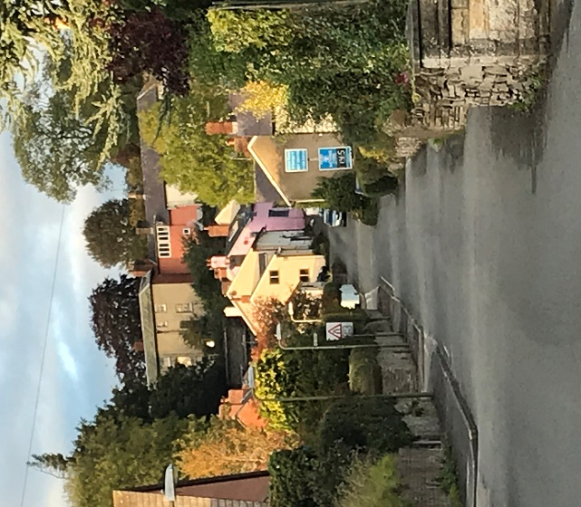  Save for the long stretch of road itself, the focal point in the distance at the top of the hill is the row of ‘grand’ houses on Welsh Street, backed by mature trees in the Castle Hotel gardens and on the Castle Land. In the foreground several openings can be seen: on the east, to Harley Jenkins Street and then to the Union Street Garage; on the west, a small cul-de-sac (still part of Union Street), and then the entrances to Stonehouse Hospital and Care Home and to a small residential development at Billingsley Close.  The road begins to slope steeply upwards at this point affording views of 19th and 20th century houses and, further up the hill, much older cottage-style properties painted attractively. There was no parked traffic in this section of the street to impinge on the view.  Reverse view: – from Laburnum Alley to the south  Looking back down the hill, the dominant view is of the long straight stretch of the road. The only buildings totally visible are Nos. 9 and 11 at the bend at the bottom. Otherwise, the line of sight is obscured on the west by shrubs and trees. On the eastern side of the carriageway Nos. 32 and 34 block the view beyond. | VN |  | N |  | 0 |  | P | VP
 | X |  |  |  | X  X  X |  | X  X  X
- COMPONENTS of the STREETSCAPE from Pound Cottage towards Laburnum Alley  At the time of day that the survey was undertaken, the first few yards of this zone on the western side were in deep shade which gave some sense of enclosure. At the southern end of the street, single story buildings and several staggered openings on both sides of the street, together with an extensive sky-scape, contributed to a very light and open feel.  On both sides of the street the walls bounding the buildings display an interesting variety of materials, styles and colours. One unpainted brick house (The Gables), where the street begins its rise, has followed the fashion in town by painting its garden wall an attractive blue colour.  Along the west side of the street, from Pound House to the north:  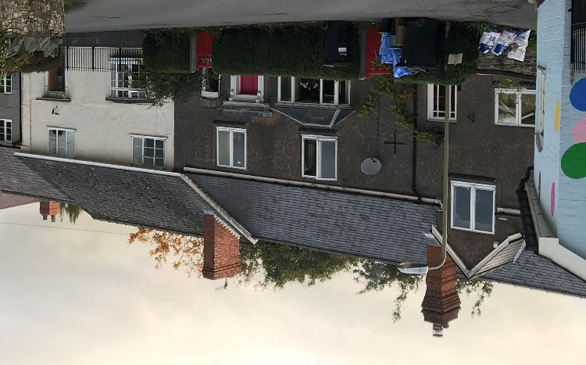  Pound House is one of only a handful of houses in the town that does not follow the characteristic style of painting rendered buildings, giving it a rather sombre appearance. It is topped by an interesting and decorative, but probably relatively new, tall chimney stack. The right-hand door has a flat-topped canopy of a style that is evident elsewhere in the street (Nos. 2, 7, 11, 14, 29, 31) and in the town centre as well as a gabled, dormer window, also a prominent feature in the Conservation Area.  Pound House and the adjoining no. 11 are both classified as non-designated heritage assets  The adjoining property to the north (No. 11) has a continuous front with No. 9 but a stepped roofline and an extension to the north with a lower roofline. At the time of the survey this extension was being demolished with a view to rebuilding.  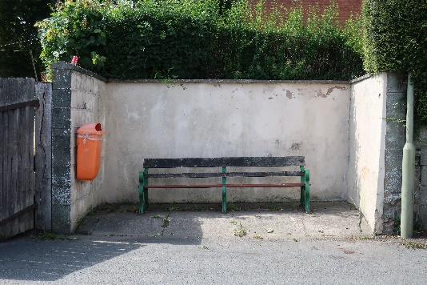  Adjacent, and alongside the pavement, is a recessed seating area with a wooden bench. Reportedly, this was the site of the former girls’ lavatory for the school canteen. Whilst undoubtedly useful this area is rather shabby and does not enhance the streetscape.  Immediately to the north is the junction with Corporation Street which slopes upwards steeply for a few yards. Past this is the former MEB building, detailed in Section C.  On a small cul-de-sac are the police station and two modern detached houses, Beech House and Applegarth. The houses are built of materials similar to those on Pound Close (described in the final section of this Zone 7 survey).  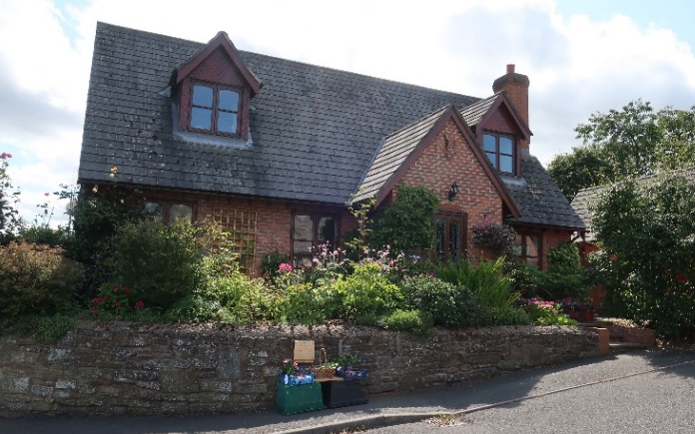  They have a very different feel to Pound Close, however, possibly because with their gabled, dormer windows they give a nod to much older properties in the town. Their gardens are well planted and now mature, again adding to the attractiveness of this area and providing welcome softness which is in marked contrast to the hard landscaping of the car park on Harley Jenkins Street opposite.  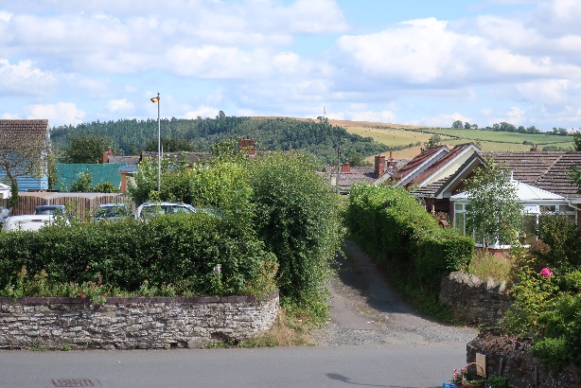  From the driveway of Applegarth there are lovely extensive views over the roofs and rear of houses on Church Street and Harley Jenkins Street towards Oakley Mynd in the distance.  The shut opposite Applegarth travels through the old burgage plots to Church Street. Alongside it is the Harley Jenkins car park.  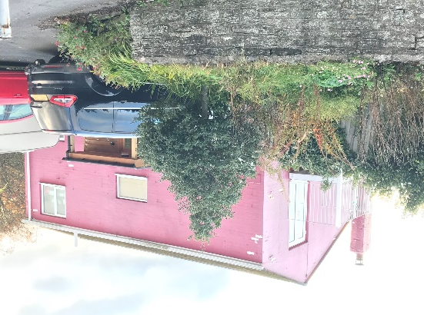  The next building, Bantry House, brightly painted (but in need of repainting) and with its side elevation facing the street, is reportedly the former workhouse warden’s house. Like the former MEB building before it, it appears to sit high above the carriageway. This is partly because of its interesting balcony at first floor level, accessed by French doors. It shares its entrance with that of neighbouring Stonehouse residential home for older people (operated by Coverage Care). Under the same roof as the care home is the NHS Community Hospital the entrance to which is from Billingsley Close, just beyond Bantry House.  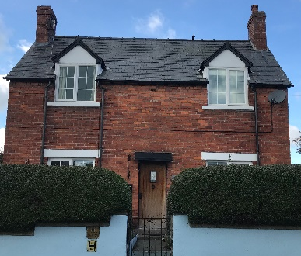  A small patch of grass planted with a tree on the corner of Billingsley Close provides a softening effect. The adjoining unpainted brick house (The Gables) is probably Edwardian and is a non-designated heritage asset. It has a pleasing symmetrical frontage with gabled dormer windows.  The Gables  Next door, Highfields is a rendered and painted bungalow, probably dating from the 1950s. It appears to be the only building in the street dating to this period and seems slightly out of place in this setting, amongst a group of buildings that are non-designated heritage assets. A driveway leads to No. 17, also a non-designated heritage asset. It has been completely modernised and is out of view of the main street.  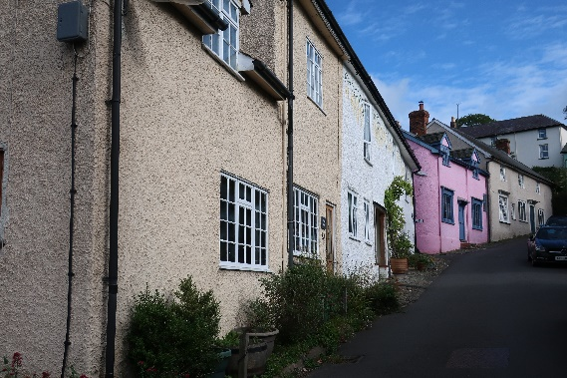  The road begins to slope steeply upwards at this point and the street begins to take on a different character, much older and more akin to that of Market Square at the top of the hill. The bend in the road invites further exploration. The first two houses in this section of the street, nos. 18 and 19, have an unbroken frontage but are different in appearance. The Old Smithy (No. 18) has a broken roof line. It was formerly a house and blacksmith’s shop, the shop later becoming a carpenter’s shop.  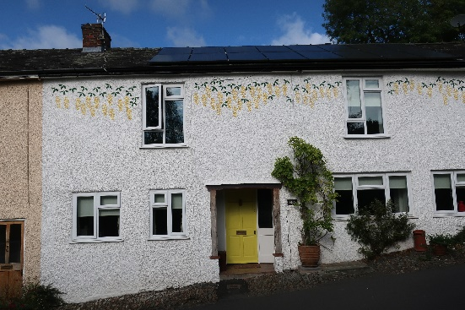  No. 19, classified as a non-designated heritage asset, was The Hit or Miss pub c.1832-1915. It has modern windows in a variety of styles that are not necessarily appropriate for a building of its age. The eye is distracted from this to some extent by the fairly recent addition of trailing laburnum painted on the front elevation at first floor level. Like the mural on Pound Cottage, this is a style of decoration that is now a characteristic feature of the town.  On the east side of the street from the right-angled bend going north:  Three large modern bungalows that sit in generous plots and date to around the 1960s/1980s are located at what was once the western boundary of the burgage plots. The track that is now Union Street originally provided the rear access to the plots behind the properties along both Church Street and High Street to enable transport of the produce and animals that were the fruits of this land. Unlike the areas further north along Union Street, it is no longer possible here to get any visual sense of the historic use of the land before the 20th century development took place.  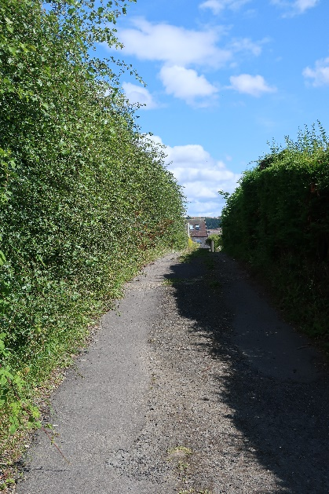  The middle of the three bungalows takes its name from the orchard which grew on this land previously. All three have substantial planted frontages so the bungalows themselves are not prominently sited.  Beside the last bungalow and at the rear of the Harley Street carpark, a shut (narrow lane) leads through to Church Street. From the Union Street end the only building visible from the shut is the roof of a property at the rear of Church Street, beyond which is the hill, Oakley Mynd. The narrow shut, with its gently sloping track and tall hedgerow provides a rural setting.  Looking east along the shut at the Union Street entrance  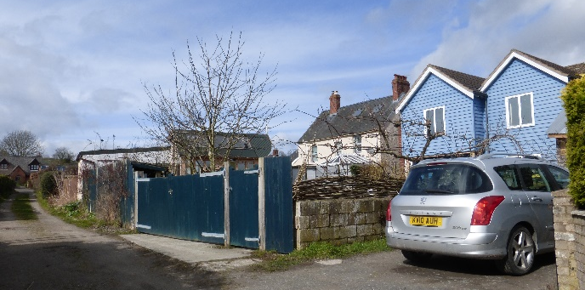  There has been some later infill building on both sides of the shut and when approached from the Church Street end this is very visible. It is, however, particularly interesting in that the shut reveals the full length of a medieval burgage plot.  The shut looking west with Beech House on Union Street visible at the end  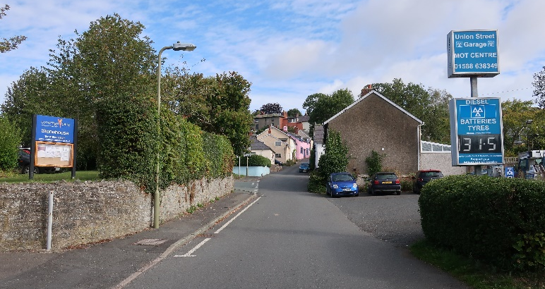  The road begins to slope upwards past the entrance to Harley Jenkins Street. The rear of an Edwardian house (Oakdene) that fronts Harley Jenkins Street has an adjoining single-story building of apparently much earlier date. The two Union Street garage commercial signs, which are at right angles to the frontage, do not enhance the streetscape and detract somewhat from the view up the hill. The garage occupies a large plot which was formerly a smithy and saw pit. Whilst functional, it sits slightly unharmoniously in what is largely a residential area. It presents an appearance similar to that in the lower part of Station Street.  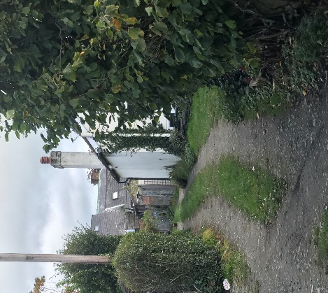  To the north, are two reportedly 19th century cottages (Nos. 22 and 28). As their numbering suggests, these were formerly four and are registered in the Historic Environment Record as non-designated heritage assets. Along the gable end of No. 28, another shut leads to the rear of Nos. 19, 21 and 23 High Street, buildings which date to the 16th century, again demonstrating the full length of a burgage plot.  The shut alongside no. 28 with sight of the roofs of the Grade II Listed Buildings on High Street. The white building on the right is no. 30 and in the foreground on the left, is the frontage to no. 32a  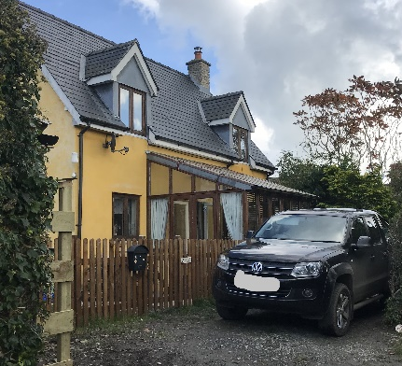  Like the shut to the south of the car park, later infill building (Nos. 30 and 32a) is very noticeable, yet the shut retains a sense of its earlier use for food production. No. 32a is of recent construction but, with the surrounding trees and shrubs, as well as dormer windows and brightly painted, rendered walls, it is very much in keeping with older buildings in the vicinity and it continues the link between the historic and modern decorative styles. No. 32a  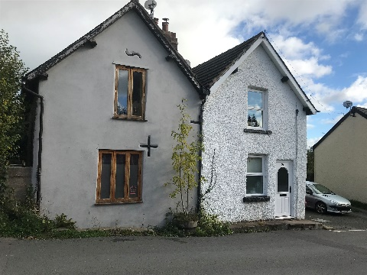  Two further adjoining cottages (Nos. 32 and 34), both of which are also non-designated heritage assets, have been modernised in different styles that are not harmonious with each other. One of these is reputedly a former Methodist chapel or meeting room. No. 32 has a garage and an adjoining workshop to the side of the property. These are rather shabby but are set well back and thus not obtrusive.  At this point in the street, looking back to the south, the elevation in ground level provides the first sight of Bury Ditches, an important Iron Age hill fort and settlement that sits on the opposite side of the A488, just south of the town.  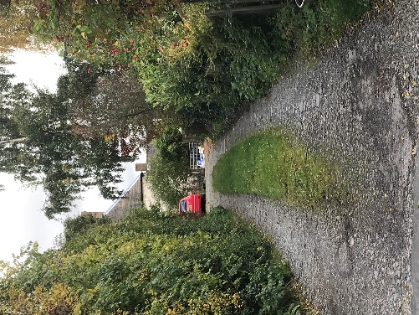  Further hedging and trees almost obscure another modern house (No. 35) with its side elevation to the street. It is built in the style of No. 32a and also sits well in its surroundings. Its rear elevation bounds the third and final shut on this side of Union Street which leads to the rear of the Porch House on High Street. Even at this distance, and from the back, it is evident that the Porch House is a significant building.  Another shut with a ‘rural’ feel and sight of the rear of the Grade II* Listed Building on High Street, the Porch House | VN  VN  X  VN  VN  VN |  | N  X  N  N  X  N  X  N  X |  | 0  X  X  0  X  X  0  0  0  X |  | P  X  X  X  P  X  X  P  X  X  X  X  X  P  X  X  X  X  P  X  X  X | VP  VP  X  X  X  X  VP  VP  VP
C. DETAILED DESCRIPTION of SIGNIFICANT ELEMENTS of the streetscape from Pound Cottage towards Laburnum Alley  This section of Union Street runs roughly parallel to the main streets in the town: Church Street and High Street. It has a very different feel to the main street, however. Despite housing three important functional buildings in the Bishop’s Castle community - the police station, Stonehouse residential home and the community hospital - there is much less traffic than on the main street. Even at the junction with Harley Jenkins Street it is less heavy than might be expected given that this is a main thoroughfare to the car park, the Co-op and High Street. To the north of Harley Jenkins Street traffic is surprisingly light. There are few visitors in evidence; pedestrians appear purposeful. The general ambience is pleasant and functional.  A sense of openness in some parts of the street is provided by views through gaps in the street frontage, both to other streets and down shuts. In contrast, in other areas there is a feeling of enclosure provided by the presence of trees, shrubs and hedges which also serves to soften the effect of new buildings.  The wide assortment of buildings in terms of age, architectural style and the purpose they serve, coupled with the way they are interwoven, strongly reflect the way in which the town has developed. Most are domestic dwellings but there are also several amenity buildings and one evident business.  There are almost as many properties that were built in the 20th/21st centuries as those of an earlier date but this does not feel like a modern part of town.  This is due in part to the fact that most of the later build is set back from the main thoroughfare, Union Street, in the area that was historically devoted to animal husbandry and food production. Later infill in the former burgage plots has generally been sympathetic and the shuts evidence the town’s medieval history. The old and the new therefore sit together harmoniously.  Domestic garages serve a useful purpose; those set back from the road, even slightly, are far less obtrusive than those flanking the street. What provides a discordant note is the older properties that have been unsympathetically modernised without acknowledging their original features or the buildings around them.  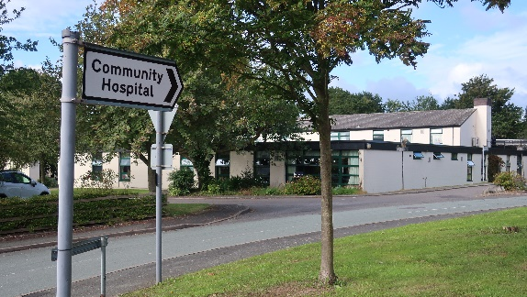  The most significant building is Stonehouse and the Community Hospital. It occupies the site of the former Clun Union Workhouse, built in 1844, and from which the street takes its name. An aerial photograph shows that for a very short time the old and new buildings stood side-by-side until the workhouse was demolished in 1964¹. Unlike its visually gaunt forebear, Stonehouse is not dominant in the streetscape, being partially single story, set further back from the road and to some extent obscured by soft landscaping.  The other important building from a functional, if not an architectural, perspective is the police station which occupies a single storey building in the small cul-de-sac alongside Beech House and Applegarth. It follows the common style of being rendered and painted. Save for the signage indicating its purpose, it could easily be mistaken for a domestic dwelling.  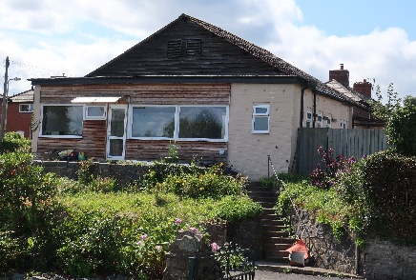  The former Midlands Electricity Board building is included here because of its dominance in the streetscape due to its elevated position. This is an unsightly rather ramshackle building with a corrugated roof. It was originally the MEB showroom and warehouse. There is an electricity sub-station to its rear on Corporation Street. The building later became a carpet shop and is now two houses, one accessed from Corporation Street and the other from Union Street, but both with addresses on Corporation Street. | VN  VN  X  X |  | N  N |  | 0  0 |  | P  X  X  X  X  P  X  X | VP  VP  X  X  X
A. VIEW (iii) of UNION ST. from Laburnum Alley towards Market Square  View 1 – from Laburnum Alley to Black Lion House driveway  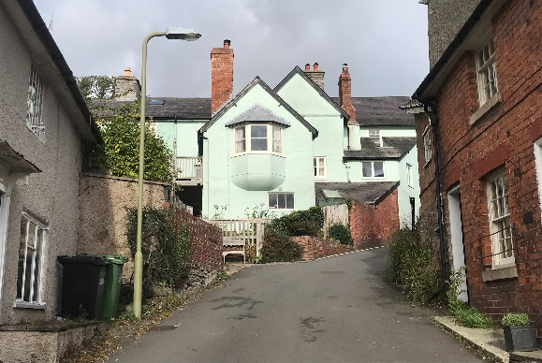  The view is relatively short due to the right-hand bend in the road as it approaches Market Square, which is not yet visible. The road inclines steeply upwards. The bend obscures the view of houses at the top of the street on the right. The focal point is the rear of Black Lion House on Welsh Street. To its left the rear of other imposing houses on Welsh Street can be seen. There are glimpses of trees in the Castle Land beyond. Despite the narrow street and the buildings on either side, the skyscape is large. The only gap visible is the driveway to Black Lion House.  View 2 – from Hillington (No. 31) towards Market Square  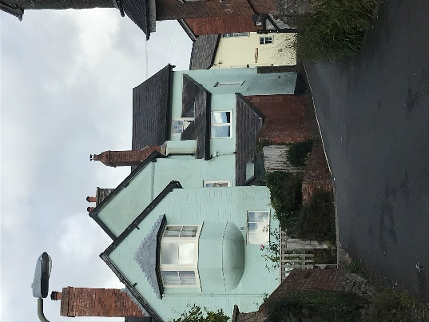  From Hillington (No. 31), Poppy House on Market Square can be seen for the first time. In a further few yards a little more of Market Square becomes visible. Other buildings on Market Square can only be seen at the junction of the two streets. The steep gradient of the road is particularly noticeable and the way it bends invites further exploration. A few yards further on there is still some enclosure. However, there is a greater sense of openness than there was just a few yards further back, created by the combination of the view ahead of Market Square and to the left and right, a parking area in the garden of Black Lion House and an entrance to an alley that runs parallel to Market Square. Large mature trees in the gardens at the rear of houses on the south side of Welsh Street are also visible.  Black Lion House is prominent in the view from Hillington  Reverse view:  View 1 – from Market Square to No. 29  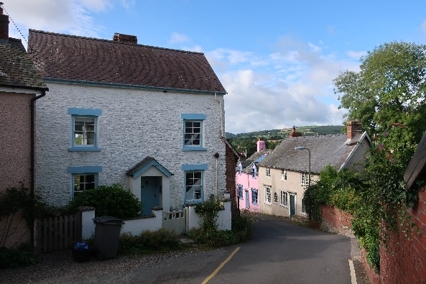  The bend in the road makes this view short. Only Hillington and part of No. 29 can be seen. There is an extensive landscape view with trees in the lower reaches of town, fields at Woodbatch and trees on Colebatch Hill. A few yards further down the street, No. 29, Hillington (No. 31) and Tudor House (No. 42) form a visual horseshoe, whilst beyond the extensive views to the hills to the south can still be seen. The whole presents a charming view, possibly one of the most attractive in the town.  The view with Tudor House in the foreground  View 2 – from Laburnum Alley/No. 19 to the south  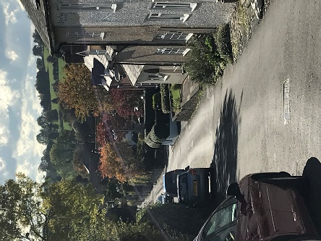  The surrounding countryside and hills are even more significant to the view at this point. As is the soft landscaping on the roadside and gardens of the premises along the western edge of the carriageway which camouflages the properties within them.  The curve in the road ensures that nothing is visible on the eastern side other than the vehicles parked along the edge of the road. The lack of pavements on both sides reinforces the sense of a country lane rather than a town centre street. | VN |  | N |  | 0 |  | P | VP
 | VN |  | N |  | 0  X |  | X  X  X  X  P  X | X  VP  X
- COMPONENTS of the STREETSCAPE from Laburnum Alley towards Market Square  In terms of the built environment, this section of the street bears a stronger resemblance to the older parts of town than it does to the rest of this zone. The buildings, although displaying frontages of different materials (stone, brick and painted and unpainted render), have a harmonious feel and provide a sense of cohesion. None of the buildings have a negative impact on the streetscape.  Only two of the buildings in this section of Union Street are listed: Black Lion House on the west side, at the corner with Welsh Street; and opposite, the outbuilding to 17 Market Square. All however would appear to date from the 18th / 19th centuries and four of the other five premises are classified in the Historic Environment Record as non-designated heritage assets. The road is steep, narrow and without a pavement throughout this section of the street. Coupled with all buildings on both sides directly abutting the road, this creates a great sense of enclosure.  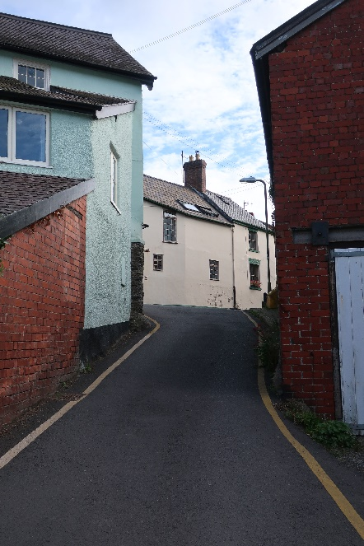  At the time of the survey there were no parked cars outside Tudor Cottage (No. 36), which provides the only opportunity for on-street parking in this section. However, this is one of the most difficult stretches of road in the town to navigate due to the extreme narrowness at the top, the steepness and the bend in the road which obscures the view of oncoming traffic. The wide entrance to the alleyway in front of Tudor House and particularly, the opening to the parking space opposite at the rear of Black Lion House (private land) provide welcome, if less than ideal, opportunities for passing on this part of the street.  The top of Union Street with the entrance to the alleyway in front of Tudor House just visible in the right foreground. The bend in the road starts just beyond this alleyway.  The uppermost buildings on either side of the carriageway do not have a Union street address. On the western edge, is the east elevation of Black Lion House whose frontage is on Welsh Street. Opposite are two stone outbuildings (Grade II listed) which are attached to No. 17 Market Square. The lower outbuilding has a brick southern elevation with garage doors, a pedestrian door and a short door at first floor level.  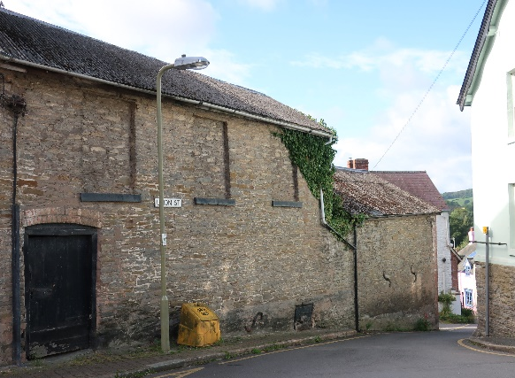  The higher building has three blind windows at first floor level and only a door at ground floor level. The three blocked-in windows are remnants of the Window Tax, a wealth tax introduced by William II in1696 and which lasted until 1851. A standard tax was imposed on all premises with glazed windows with an additional levy according to the number of glazed windows on the property. Several of the older properties in town exhibit the effect of the Window Tax.  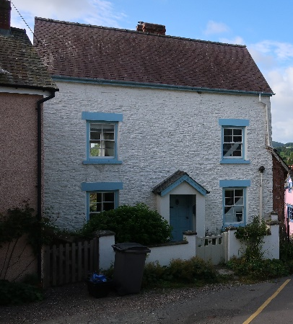  At the end of this building is an alley which runs parallel to Market Square. The first building on the south side of the alley is set at right angles to the carriageway. This is Tudor House (No. 42) which is detailed in Section C.  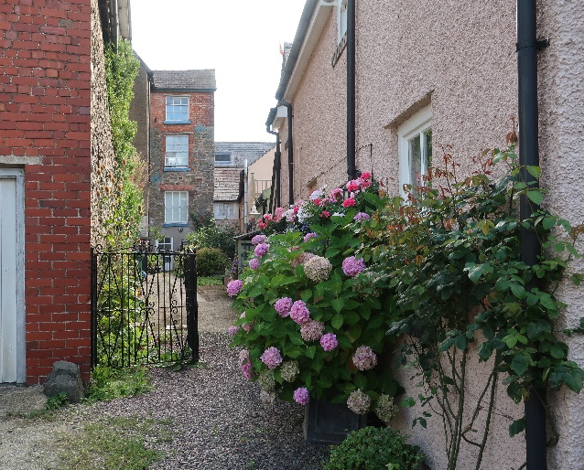  Alongside Tudor House is No. 44, a detached rendered house of unknown age with dormer windows and attractive planting in pots to the front. It is recorded as a non-designated heritage asset. A gateway leads further down the alley to No. 13 Market Square. A view can also be seen of No. 41 High Street and the first floor of the rear of the House on Crutches (both Grade II* listed) which is also on the High Street. Along the northern edge of the alley is the rear of Nos. 13, 15 and 17 Market Square (all Grade II listed). The substantial height of these three buildings and the narrowness of the alley provides a great sense of enclosure.  The tall brick and stone building with three windows at the end of the alley is 13 Market Street  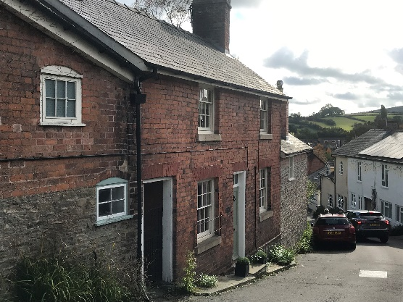  Tudor Cottage is attached to the gable end of Tudor House. It is a complex of buildings that runs along the carriageway. Largely of brick construction, the house itself probably dates from the Victorian era. It is of pleasing appearance and seems to have retained its original windows. A passage from front to back, over which the upper floor flies, is enclosed by a wrought iron gate and gives a glimpse of the rear of the property.  The main building has other buildings attached to it. To the south is a single-story stone building which forms an integral part of this dwelling. To the north and possibly only accessed from the main building at first floor level is another building which is stone at ground floor level and brick at first floor level. This is the section of the complex that adjoins Tudor House.  Immediately beyond Tudor Cottage and opposite the entrance to Laburnum Alley, are two gardens, also with direct access onto the street.  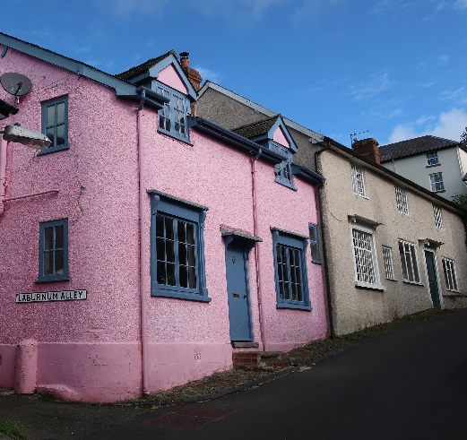  Abutting the western edge of the carriageway are just two houses: No. 29 with its striking, pink and blue appearance (detailed in Section C) and Hillington which has a long front elevation with, at ground floor level, a door and four windows, of different styles and sizes. It appears plain in comparison with its brightly painted neighbour but is recorded as a non-designated heritage asset in the Historic Environment Record. Planting atop the wall of the rear garden of Black Lion House, just beyond Hillington, softens the hard landscaping.  Leading up to Market Square the street is very narrow, the carriageway being only a car’s width. Almost at the junction with Market Square there is a good deal of street furniture: a no waiting sign, a streetlight, a telegraph pole, a grit bin and bollards on the junction itself. | VN |  | N |  | 0 |  | P | VP
 | X  VN  VN |  | N  N  X |  | 0  0 |  | X  X  P  X  P  X  X  X  X | X  X  X  VP  X  VP
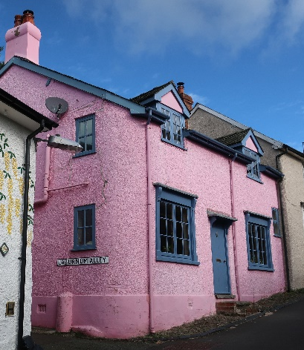  C. DETAILED DESCRIPTION of SIGNIFICANT ELEMENTS of the streetscape from Laburnum Alley towards Market Square  No. 29 is attractive and probably the most eye-catching building in the entire zone. It is, however the only one of the seven buildings in this section of the street that does not feature as a heritage asset.  Although modest in size it is striking, in part due to its position on the street, but largely because of the colours in which it is painted – bright pink and bright blue. Whilst the front elevation can be seen from as far away as Pound House (No. 9) at the bottom of  the hill, from Laburnum Alley it becomes even more striking because at this point the side elevation is also visible. In common with several other houses on Union Street and elsewhere in the town centre, it has dormer windows.  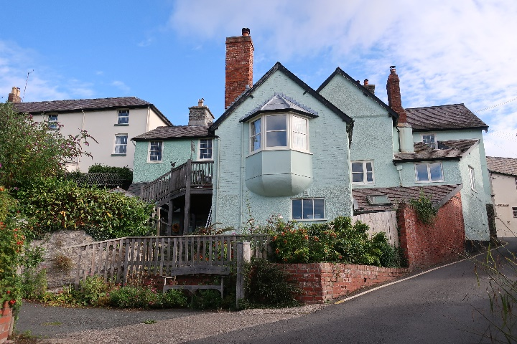  Black Lion House (rear). Although this house (Grade II listed) is technically on Welsh Street, its eastern elevation is on Union Street. It can be seen from many parts of the town and the surrounding area. Its southern elevation is imposing as far as Union Street is concerned for several reasons: it is directly in the line of sight in this stretch of the street; it is in an elevated position due to the steep upward slope; it is rendered and painted a pale green colour; it is three stories high and has a wide rear elevation that is stepped and in a variety of styles which includes an interesting first floor bay window.  The house, formerly a pub from 1791 to 1990, appears to have been extended to the south in several phases and in a haphazard fashion but the whole is not inharmonious. This is a much more imposing building from the rear than from the front and is a dominant part of the streetscape in this section of Union Street.  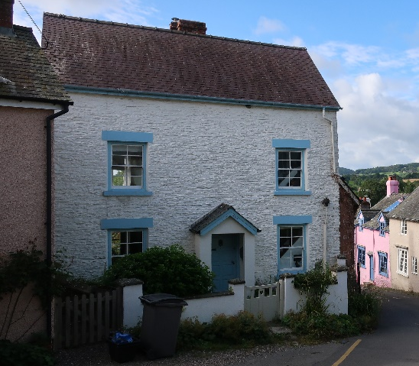  Tudor House (No. 42) is the first house in the alley to the east of Union Street. It is barely noticeable when proceeding up the hill. Coming downwards, however, it is more prominent because its side elevation is adjacent to the street and its front faces north. This, together with the bend in the road puts it directly in the line of sight when looking south. It probably dates from the 18th century and was reportedly a button factory. It is visually pleasing, having an enclosed but visible forecourt and a symmetrical frontage with a portico. Its front elevation is of stone which is painted attractively in white offset with blue.  General ambience. The historic feel of this section of the street predominates. Its attractively decorated buildings which sit well together, along with the expansive views from the top of the hill, make it a very pleasant part of the town. Driving here can be problematic but it soon gives way to a wider stretch of road further down the street. At the time of the survey there was no traffic movement, no parked cars and only one person on foot. There was no intrusive noise. All this served to make the area feel peaceful. | VN |  | N |  | 0 |  | P | VP
 | VN |  | N |  | 0 |  | P | VP  X  X  X  X
- VIEW (iv) of LABURNUM ALLEY from Union St. through to both Oak Meadow and Welsh St.  Laburnum Alley is a pedestrian thoroughfare between Union Street and the housing developments around Oak Meadow. It also has an offshoot to Welsh Street.  Whilst the main footpath is long and by and large straight, slight turns along the way result in a series of four separate views. The offshoot to Welsh Street is much shorter but zigzags to create three distinct views.  Laburnum Alley  View 1 – from Union Street to The Garden House garage. The initial view from the entrance to Laburnum Alley is only a few yards. The alley is at its widest here but it is still little more than a car’s width and the two houses on either side of the entrance, Nos. 19 and 29 Union Street, give an immediate sense of enclosure. To the right, at the back of these houses, there is a gap providing a view of the rear of several imposing houses on Welsh Street and on the left is a glimpse of No. 17 which sits directly behind the street frontage property No. 19. The focal point ahead is the garage of The Garden House.  View 2 – from The Garden House garage to the alley leading to Welsh Street. The initial view is of The Garden House to the left and thereafter a long, linear view dominated by a long, high brick wall, also on the left. The path slopes upwards slightly until the point of View 3 which is approximately halfway along the main footpath.  View 3 – westward from the bottom of the alley leading to Welsh Street. This is a long straight view again dominated by trees, hedges and the high brick wall. At the end the path bends slightly to the left. The ground slopes downwards.  View 4 – last few yards of Laburnum Alley to Oak Meadow. The ground continues to slope downwards and the end of the path can be seen. The focal point is a fence at the rear of a house on Oak Meadow.  The Welsh Street offshoot  View 1 – from Laburnum Alley to Sunny Bank (No. 21). The view is long, narrow and straight with lots of vegetation along the route and a stone wall and small wooden outbuilding directly in the line of sight. The ground slopes moderately upwards.  View 2 – from Sunny Bank to the rear of Nos. 17 and 19 Welsh Street. This is a very short stretch of the path which slopes upwards slightly. The view of trees, hedges and walls that has dominated since the start of View 2 is finally broken by a view of the rear of tall imposing houses on Welsh Street.  View 3 – as the path turns north to exit onto Welsh Street the properties Nos. 16 and 18 provide a visual stop on the opposite side of the carriageway. |  | VN |  | N |  | 0 | P | VP
X

X

X

X

X

X

X

X

- COMPONENTS of the STREETSCAPE of LABURNUM ALLEY from Union St. through to both Oak Meadow and Welsh St.  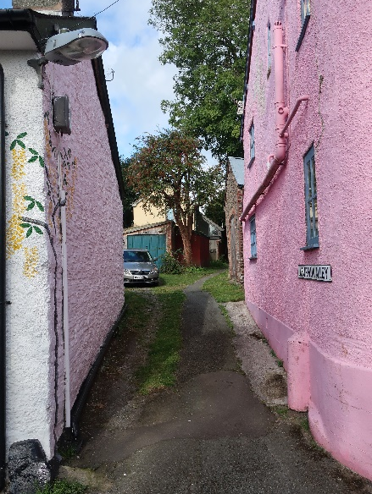  The entrance to Laburnum Alley is constricted by the gable ends of Nos. 19 and 29 which sit immediately on either side of the track. Initially it is just a car’s width and its surface has in part been tarmacked but beyond these walls the track narrows to a path and the area opens up slightly.  From here there is rear access to Nos. 17, 19, 29 and 31 (Hillington). Immediately ahead, on the left-hand side of the alley, is the garage to The Garden House, with the house itself right behind. On the right, an apparently old stone garage belonging to No. 31 has been created in what might have once been a workshop.  The Garden House is a modern ‘eco’ property, from this view apparently not dissimilar to Nos. 32a and 35 Union Street. The three properties have in common that they are built in shuts or alleyways, rendered and painted yellow.  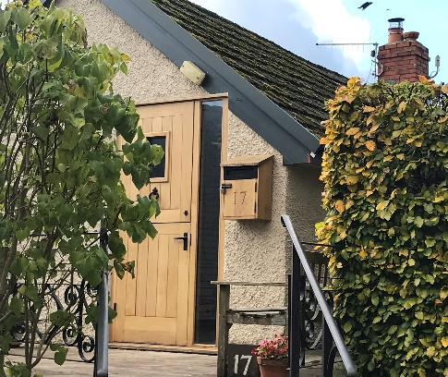  There is an extremely limited view of the non-designated heritage asset, No. 17 which sits directly behind the street frontage property No. 19 and is surrounded by vegetation. This property has been extensively renovated, such that it is difficult to recognise its historical origins from its exterior appearance. Nevertheless, the modern visual impact of the renovations and its setting is pleasing to the eye.  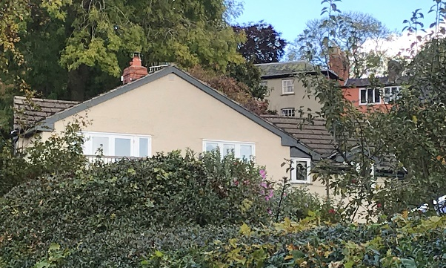  No. 17, viewed from Laburnum Alley  and from Billingsley Close  An opening on the right provides a view to the extensive rear gardens of imposing properties on Welsh Street. These are now used as allotments. There is no indication which garden belongs to which house. Old stone walls are in evidence but it is uncertain what they might originally have been. A curious looking very small brick building in one of these gardens was reportedly once a lavatory. This area is said to have been a field for horses from the Black Lion pub. In the first garden there is a life-size steel sculpture of a sheep, a work of the late Roger Williams.  After The Garden House the tarmac gives way to a gravel/earth footpath. This continues right to the end of the alley and continues up the side alley leading to Welsh Street.  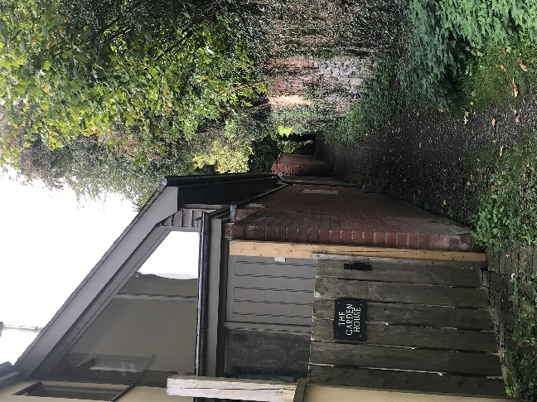  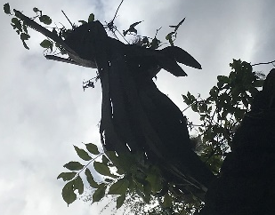  On the left of the path a high new brick wall bounding the garden of The Garden House gives way to a much older wall of the same height (around 7’). Just before they meet, atop the wall, is another life-size steel sculpture, this time of a hare.  The wall is so dominant from here right to the end of the alley that the eye, looking for variation, tends to be drawn to the right where the boundary, an old stone wall topped with a mixed hedge, is lower and less dense. The sun is reaching this section of the path. There is a sense of wanting to move on to explore further.  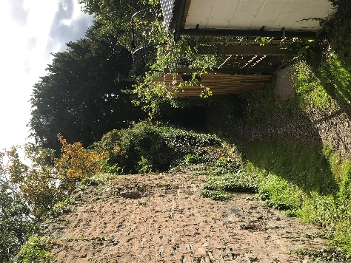  Around half way along the alley, on the northern edge, is a junction with a side alley that forms a 90º turning. This second path slopes upwards. There are allotments on the east side beyond an old stone wall. On the west hedging and fencing bounds the garden of a very secluded, most attractive, old stone cottage, with painted walls, which is Sunny Bank but has the address 21 Welsh Street. Another steel sculpture can be glimpsed in this garden.  Looking towards Laburnum Alley with Sunny Bank to the right  The path turns sharply to the east again and after a short distance opens out to an area of land at the rear of Nos. 17 and 19 Welsh Street. These tall buildings and outbuildings give this space a sense of enclosure but the area feels much more open and urban than in the alley itself.  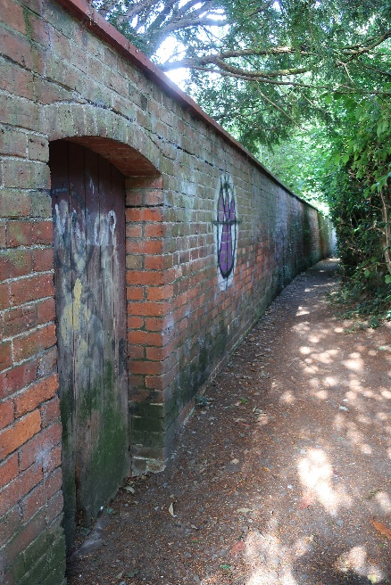  Back on Laburnum Alley, opposite the sloping path leading to Welsh Street, a wooden gate in the brick wall and the wall itself have graffiti on them. From here on the path becomes even more enclosed because the high stone wall on the south side continues and there is also now a high hedge along the northern edge of the path. Branches arch over the top creating a tunnel effect. This area is in deep shade. Two separate gates on the right give views of vegetable gardens.  In the last few yards, the path and wall bend very slightly to the left. The path then meets a path that runs between the back of Oak Meadow and the back of Billingsley Close. Laburnum Alley then opens out into a large, grassed area at the top of Oak Meadow where an electricity sub-station is sited. There is a huge contrast in the character of these two areas. The pedestrian is immediately transported from a shady, secluded, quiet green place with no buildings to an  open area with modern housing, large sky-scapes and people going about their business. |  | VN |  | N |  | 0 | P | VP
 |  | VN  X  VN |  | N  N |  | 0  0 | X  X  X  X  P  X  X  X  P  X | X  X  VP  X  X  X  X  VP
C. DETAILED DESCRIPTION of SIGNIFICANT ELEMENTS of the streetscape of LABURNUM ALLEY from Union St. through to both Oak Meadow and Welsh St.  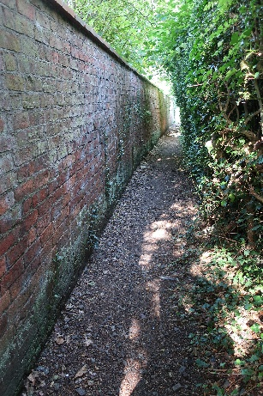  This alley is very different from the rest of the zone in that it is a footpath. There is only one house solely accessed from Laburnum Alley itself. The space is dominated by mature trees, including some yews, and a very long high brick wall to the southern boundary. Apart from the first few yards, the lack of view and reference points means that there is no sense of where this place is. The brick wall and the occasional glimpse into vegetable gardens give the feeling that this is not in the middle of the country, but that is all.  There were no people, but much birdsong. In the middle of the day it did not feel uncomfortable to be in such a quiet and secluded place; the same might not be said after dark.  It is unusual to see graffiti in the town. Presumably the perpetrators chose this space knowing its seclusion and low footfall would make it unlikely their work would be disturbed. |  | VN |  | N |  | 0 | P | VP
 |  | X |  |  |  |  | X  X
A. VIEW (iv) of HARLEY JENKINS ST. from Union St. to Church St.  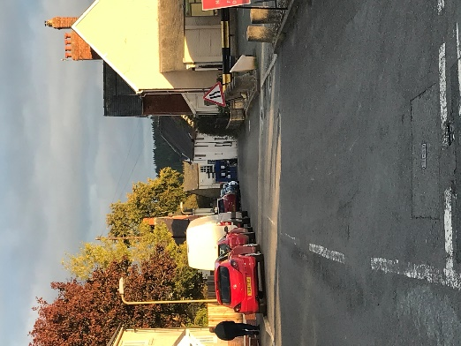  This is a linear street with a slight slope and curve to the left as it reaches Church Street. It clearly demonstrates the full length of a medieval burgage plot.  The focal point is the very unsightly former newsagent’s shop on Church Street. There are glimpses of Oakley Mynd in the distance and some trees in gardens on the left of the street.  The dominant feature is parked cars both from the public car park on the right and cars parked on the street on the opposite side. Perhaps because of the dominance of the car park at the junction with Union Street, the street does not present a clear identity.  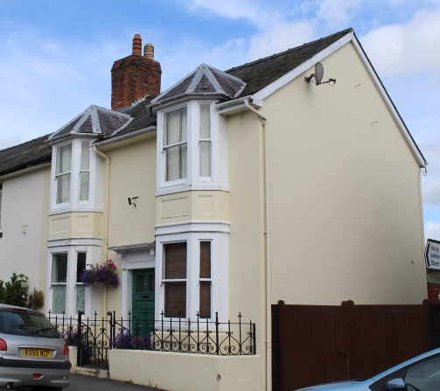  At the mid-point of the street, trees on the left provide a softening effect which contrasts with the hard landscape at the western end. Approaching the junction with Church Street, the focal point is No. 72 Church Street, a non-designated heritage asset which sits to the north of the newsagent’s and adjoins the old Post Office. This is a well-maintained period house with bay windows at both ground and first floors. Its pleasing appearance contrasts sharply with that of the former newsagent’s shop. Cars are parked along the northern edge of Harley Jenkins Street, close to the junction with Church Street.  Reverse view:  The view is right to the end of the street. The road curves very slightly to the right at the Co-op yard. The street feels narrow at this point. The dominant view is: ahead, the road surface; to the left, the long side of elevation the Co-op building; to the right, a cottage at right angles to the road. At the end the police station is clearly visible. Trees beyond give way to a substantial skyscape. Parked cars do not obscure the line of sight. |  | VN |  | N |  | 0 | P | VP
 |  | X  VN |  | X  N  X |  | 0  X | X  P  X  X | VP
- COMPONENTS of the STREETSCAPE of HARLEY JENKINS ST. from Union St. to Church St.  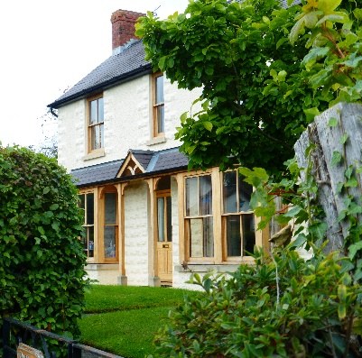  Harley Jenkins Street is a ‘new’ street in the town centre, only constructed in 1903. There is no overall uniformity in this street although three modern terraced houses are of the same style and built in the same materials. Apart from the Church Street end most buildings appear to date from the 20th century. A pavement runs along the north side only.  On the northern side of the street:  Oakdene, an Edwardian property that is registered as a non-designated heritage asset, has a pleasing symmetrical front elevation with an attractive canopy to the ground floor stretching almost the full width of the house. It is bounded by an attractive mixed hedge.  A row of three terraced houses built in 2018 stand on the site of a bungalow that had suffered fire damage. These are described in Section C.  A neighbouring rendered modern bungalow (Over Quensel) is set back from and at right angles to the street and is partially screened by mature planting including trees. A reveal in the gateway provides a sightline towards the upper part of the town including a good view of the Town Hall clock.  A garage at Over Quensel, slightly set back from the pavement, is much less obtrusive than one on the opposite side of the road at The Haven.  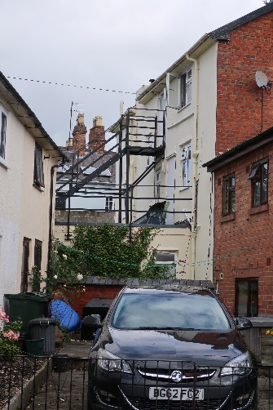  A well-built stone wall abounds a well planted garden that runs parallel to the street. This again provides a welcome softening effect to the area. The garden belongs to one or more of three adjoining cottages, built at right angles to the street. These cottages were formerly part of Wootten Square, a group of nine cottages until some were demolished in 1898 in order to create Harley Jenkins Street. The Town Hall clock can again be seen from here.  At the eastern frontage to these cottages, an opening provides off road parking for one property. A second opening leads through wrought iron gates to an off-road parking space and beyond that a small courtyard garden at the rear of No. 65 Church Street. This opening also gives an unattractive view of a substantial fire escape to the rear of 69-71 Church Street.  On the southern side of the street:  There is a very open feel in the part of the street closest to Union Street. The car park, by its very nature, has much hard landscaping and is unattractive. It is separated from the street by large, short, plain concrete bollards set into cobbled setts.  There are only two houses on this side of the street. Both are detached.  The first (The Haven), an otherwise pleasing Edwardian house with a red brick front has lost its original windows and had a porch added. The second (Sefton) appears to date to the second half of the 20th century and displays a variety of building materials. Its garden, to the side, and a narrow front forecourt are attractively planted and mitigate the prevailing hard landscape along this side of the street.  A gate gives way to the yard that serves the Co-op and then to the side elevation of the store. This is detailed further in Section C. |  | VN |  | N |  | 0 | P | VP
 |  | VN  X |  | N  X  X |  | X  0  X | X  X  X  P  X  X  X  X | X  VP
C. DETAILED DESCRIPTION of SIGNIFICANT ELEMENTS of the streetscape of HARLEY JENKINS ST. from Union St. to Church St.  Harley Jenkins Street is named after George Harley Jenkins who was born circa 1809 in Knighton². He moved to Bishop’s Castle and is recorded as being a painter, plumber and glazier in 1851³ and 1856⁴. He appears to have been self-employed and relatively well to-do, employing a glazier, a journeyman and a servant who all lived at his address² - Harley House, No. 3 High Street⁵. On his death he left both land and property to the town. It is believed he left old property on the main street that was in a dilapidated state.⁵ This was demolished to create a new access between Church Street and Union Street through what were the former burgage plots - an entry into what is now Harley Jenkins Street⁵. He died, apparently childless², in around 1890 at the age of 80⁶.  The street provides a well-used thoroughfare from the western side of town to the main street. There is a variety of buildings of differing styles and dates. Although there is nothing to provide a sense of continuity, the street does not have a discordant feel.  The car park, where reportedly three cottages once stood⁷, dominates the Union Street end. It is unattractive but highly functional and very necessary in town where parking is so challenging. It offers longer term parking to residents living nearby with no parking provision as well as to those coming to town by car. The car park is used heavily and during the daytime it is not uncommon for there to be no free spaces, though this was not the case at the time of the survey. An interpretation board in the car park is very useful to visitors but is showing signs of wear and would benefit from refurbishing.  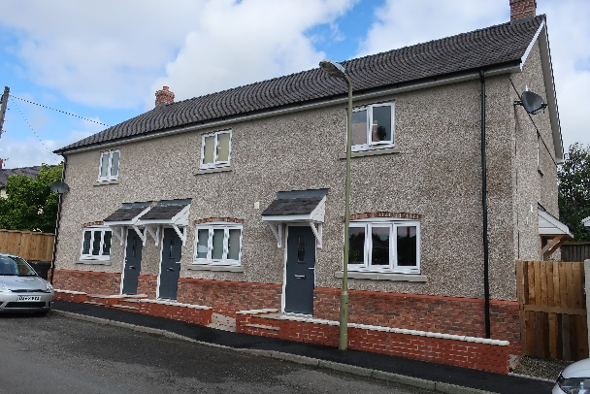  A significant recent development in the street is the construction of a row of three terraced houses close to the junction with Union Street. These have provided much needed, relatively low-cost housing. Their clever design makes excellent use of the small space the site provided. Externally, they are rendered, have canopies over the doors, feature brickwork over the windows and chimney stacks (presumably non-functional). Short, sloping paths provide access for the less physically able to the front doors which means that these do not open directly onto the pavement. Two appear to provide off-street parking. The third has new close board fencing that conceals a small garden space. Although not yet weathered, they do not have a jarring appearance in their setting.  At the opposite end of the street, at its junction with Church Street, stands the Co-op on the south side (a Grade II Listed Building) and a stone cottage, No. 65 (a non-designated heritage asset) on the north. As late as the Victorian era this area was interconnected via the Red Lion Shut, that led from Church Street to the yard at the rear of the Red Lion pub (now part of the Co-op building), and from there, via Tuggs Passage, to Wootton Square which contained 9 buildings and covered part of the current carriageway and extended to the three cottages behind No. 65. All but the three cottages behind No. 65 were demolished in 1898 to facilitate the construction of the street in 1903 and this inter-connection is now all but lost visually.  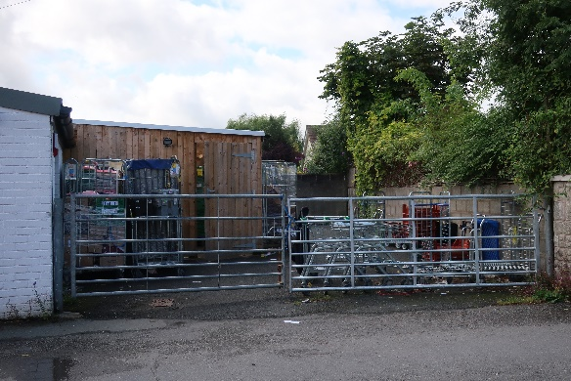  The Co-op has a high footfall. Its small footprint means that there is a high turnover of stock. The stock comes into the small yard to the rear of the building. This is untidy and unattractive and would benefit from high gates to obscure the view from the street and provide privacy.  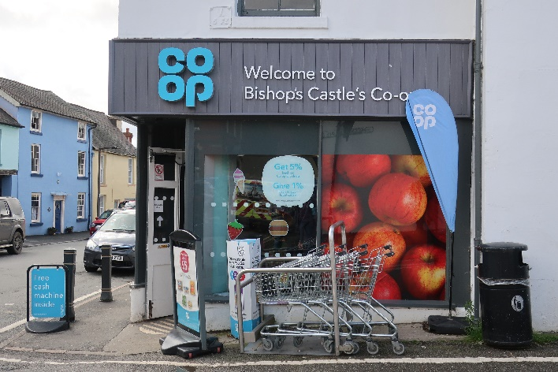  At the junction with Church Street, the street is cluttered with advertising signs, trolleys from the Co-op and a waste bin. This not only has a detrimental visual impact, but it is also a safety issue. There is no line of sight for cars turning left into Harley Jenkins Street from Church Street. The entrance door to the Co-op sits diagonally on this corner and there is no pavement past the Co-op door. Accidents have occurred in this location and may do so in future.  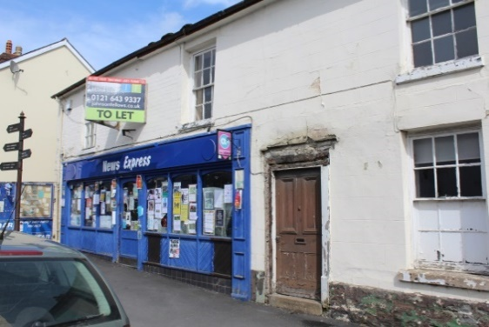  The very dilapidated former newsagent’s shop on Church Street forms the focus of the view along Harley Jenkins Street. Although a non-designated heritage asset, its condition has a very negative impact. |  | VN |  | N |  | 0 | P | VP
 |  | VN  X  VN  X  X |  | N  X  X  N |  | X  0  X  0 | P  X  X  P | VP  X  VP
A. VIEW (vi) of POUND CLOSE from Union St. to the top of the rise  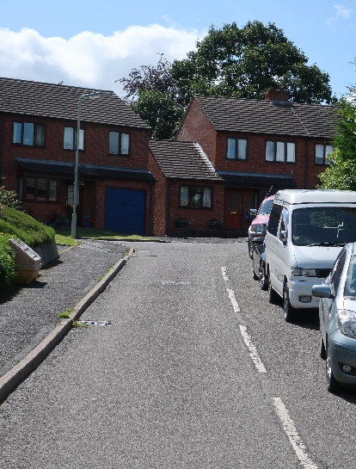  Pound Close is a short cul-de-sac which rises steeply from Union Street. The houses on the straight incline can be seen from the junction but the dwellings at the western end of the cul-de-sac are hidden from view by a combination of a slight curve towards the end of the carriageway and the garden foliage of properties fronting Union Street. The somewhat harsh appearance of the relatively new buildings here is to some extent mitigated by the trees in the park that lies beyond the cul-de-sac and by the planting in the front gardens along the eastern edge of the pavement that adjoins the straight, sloping section of the street.  Reverse view:  From the top of the incline in Pound Close, facing Union Street, there is a very pleasing view of the upper, older part of the town and, to the east, distant views of the top of the Long Mynd. |  | VN |  | N |  | 0 | P | VP
 |  |  |  |  |  |  | X | X
- COMPONENTS of the STREETSCAPE from Union St. to the end of the cul-de-sac  The street, particularly at the top of the incline, feels very open. Its elevated position provides excellent distant views to the north and east. The lower, sloping, section is sufficiently wide to provide space for parked vehicles on the west side. The gardens of two houses on the slope have low front retaining walls. The remaining houses have no boundaries to their frontages or the pavement. This lack of boundaries increases the sense of openness.  There is a stark contrast between Pound Close and the lower section of Union Street demonstrating the difficulty in introducing modern architecture successfully into an area of older buildings. Whilst there is some variation in the type of houses (three matching pairs of semi-detached houses, two detached bungalows and a detached house), they are all built in a very uniform style using the same materials of dark red brick with dark brown uPVC windows. There is no acknowledgement of materials, finishes, decorative elements or features such as the dormer windows that are prevalent in the older buildings in the Conservation Area and which have been incorporated into other new builds within this zone. |  | VN |  | N |  | 0 | P | VP
 |  | VN |  | N  X |  | 0 | X  P | VP
C. DETAILED DESCRIPTION of SIGNIFICANT ELEMENTS of the streetscape from Union St. to the end of the cul-de-sac  The uniformity in the style and materials of the buildings is the most significant element in Pound Close. The lack of a boundary between the pavement and the front gardens in most of the houses, and front gardens/driveways which are mainly of grass or hard landscaping, makes the street appear rather featureless.  Some of the cars parked on the lower section of the street belong to residents of Union Street. Whilst this could be viewed negatively, it does mean that Union Street, a thoroughfare, is less congested than it might otherwise be. The elevated position of Pound Close makes it light and airy, and there is very little traffic noise. |  | VN |  | N  X |  | 0 | P  X | VP
D. SPIRIT OF THE ZONE

In this zone, Union Street has one Grade II Listed building, with another two prominent Grade II buildings at the top end of the street, facing onto Market Square and Welsh Street and a third at the junction of Harley Jenkins Street and Church Street. In addition, there are 24 properties in this zone that are registered as non-designated heritage assets. So, whilst there is not the intensity of historic architecture that is seen on the main streets, its presence is still felt.

At first sight this space is defined by the tangible. Its buildings and those they abut are a jumble of different ages and styles that span almost half a millennium. It is a place of streets, secret alleyways and, in the old burgage plots to the north and east, of softly landscaped enclaves. There are domestic dwellings and valued public buildings, a mix of public and private spaces, all set against the backdrop of a stunning landscape which is visible both to the south and the east.

This space feels grounded and functional but this belies the strong artistic presence that is evident throughout the town. Buildings are painted in a variety of hues and two display prominent murals. On closer inspection, there are mosaics, wall decorations and a surprising number of steel sculptures, to be found in hidden places.

The older unspoilt houses clustered together on the narrow part of Union Street form a most picturesque scene, particularly when viewed from the top. The view is not dissimilar to the famous view of Gold Hill in Shaftesbury. In contrast, the few neglected buildings or insensitive alterations to older buildings have a negative impact on the streetscape. This is however counterbalanced by those sympathetic, newbuild properties that reflect the Edwardian detail that proliferates in the town, such as gabled windows in the roofline, canopied doorways and staggered facias and footprints.

This is a historic place with a solid presence and a distinct identity but it is not set in stone. In this zone, alongside historic buildings are several bungalows built in the second half of the 20th century. These are ideal for serving the needs of older people. In contrast, the three well-designed affordable houses on a small plot on Harley Jenkins Street are perhaps better suited to younger people. This recent development is to be commended and has brought the area firmly into the 21st century. As the population of the town grows two important challenges will be, firstly, to maintain/increase public and private services, ensuring the buildings that house them fulfil their needs, and, secondly, to reverse the trend of building larger detached houses that would likely result in a demographic trend towards an older population.

There remain only two noticeable undeveloped sites in this zone, along the northern edge of Laburnum Alley. These are identified on the Zone map as sensitive sites which, if development should go ahead in the future, require the character of the zone to be fully reflected. It is believed that either or both these sites may constitute the “Tenement plots south of Welsh Street” that are included in the list of non-designated heritage assets that is contained in the Shropshire Council Conservation Area Appraisal which was last updated in 2012. As this cannot be confirmed, they are not included in the zone map which identifies the heritage assets.

Traffic has a notable presence, not least because one of the town’s main car parks is located in Harley Jenkins Street. It does not appear to be generally problematic. In places however, and particularly in Harley Jenkins Street, it does create a negative image. The pinch point at the top of Union Street and the lack of pavements in parts of both Union Street and Harley Jenkins Street could create difficulties should traffic flows increase.

References

- Theobald, A. & Theobald, P. (2016). ‘Caring for the people: health and welfare’. In Preshous, D., Baugh, G., Leonard, J., Watson, G. and Wigley, A. (eds) The Story of Bishop’s Castle. Logaston Press, pp. 103-112.
- 1851 census return for Bishop’s Castle.
- History, Gazetteer and Directory of Shropshire, Samuel Bagshaw, 1851.
- Post Office Directory of 1856.
- Bishop’s Castle Heritage Resource Centre, A-Z files. Kate Price.
- St. John the Baptist Church, Bishop’s Castle, Graveyard Survey, C.160.
- Bishop’s Castle Heritage Resource Centre (2009), House History Group. Ivy M Evans.

