Bishop’s Castle Heat & Wind Survey Report, Oct 8th 2021.

We received 128 responses to the survey by Sept 30th. 6 of these have been discounted as they were too far removed from the town (Newtown, Shrewsbury, Church Stretton, White Grit, Bentlawnt and Clun).

Of the 122 responses left, 22 were from just outside the P arish and 100 from within the Parish.
The map shows the postcodes that responses were received from with one pin per postcode. There were 9 from SY7 8BS (Brockton) and three from SY9 7EY (Oakley Manor)

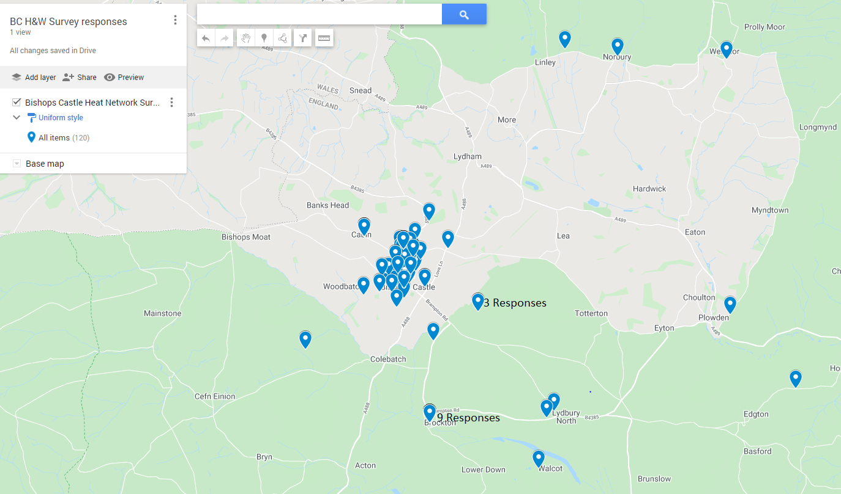

The 122 responses were:-
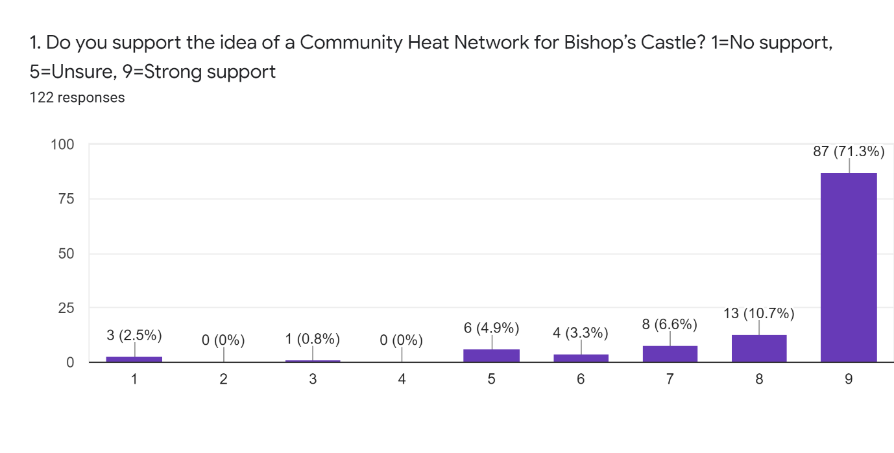
The numbers on the vertical axis represent the number of respondents giving that score
ie 87 respondents gave a score of 9 for Q1.

Of the 100 in strong support of the heat network (scoring 8 or 9) 85% live within the parish, 15% live just outside it.
Of the 3 who are against the heat network (scoring 1 or 2) 33% live within the parish, (ie 1 respondent), 66% live just outside it.
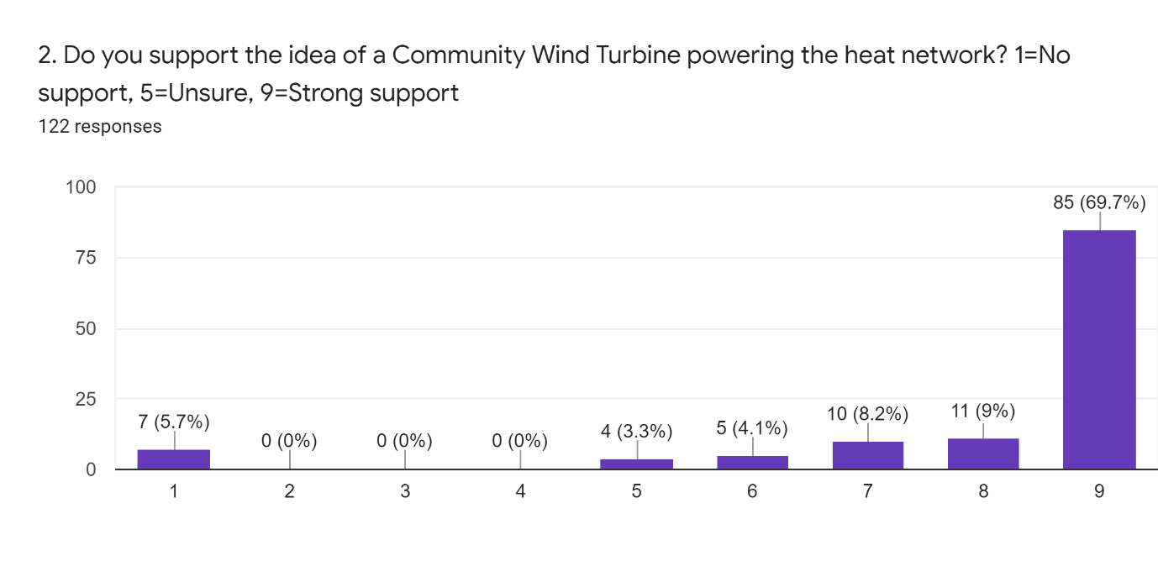
Of the 96 in strong support of the wind turbine (scoring 8 or 9) 87% live within the Parish, 13% live just outside it.
Of the 7 who are against the wind turbine (scoring 1 or 2) 28% (2 respondents) live within the parish, 82% (5 respondents) live just outside it.

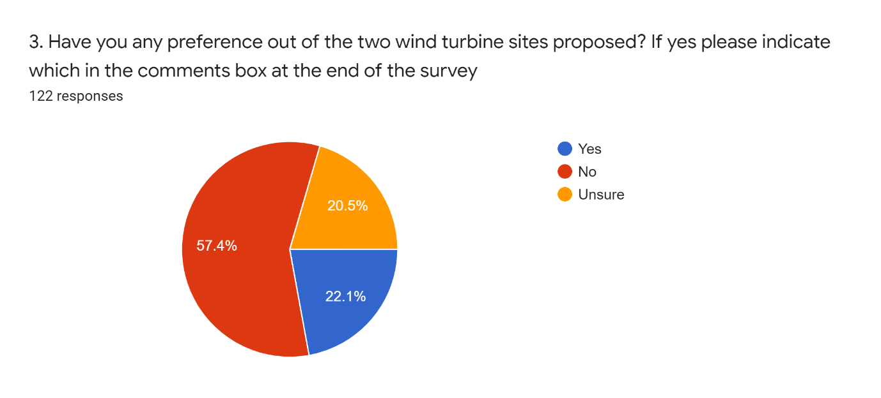
Of those who included a comment on site preference 11 voted for site B, the site between the B4385 and the Conery, 5 voted for Site A, the site east of the A488, north of the Business park.
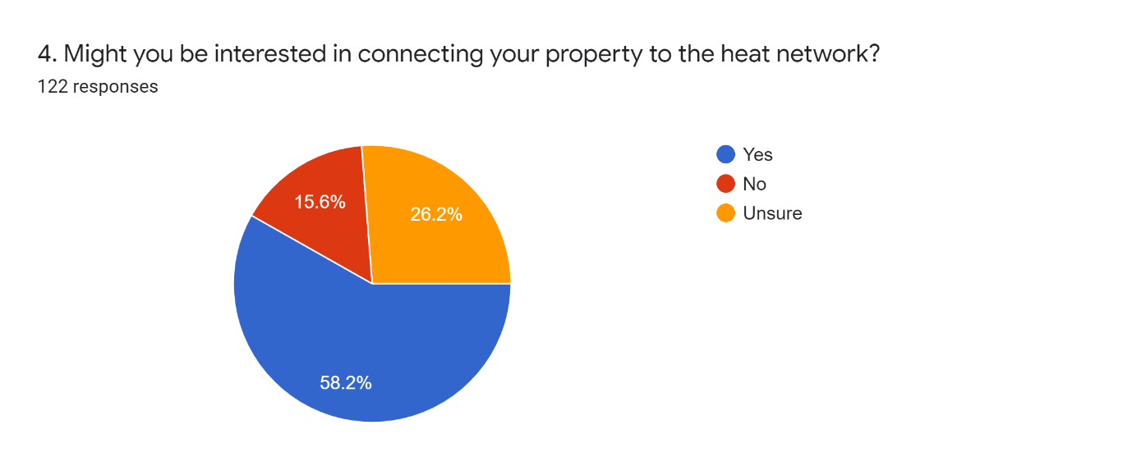
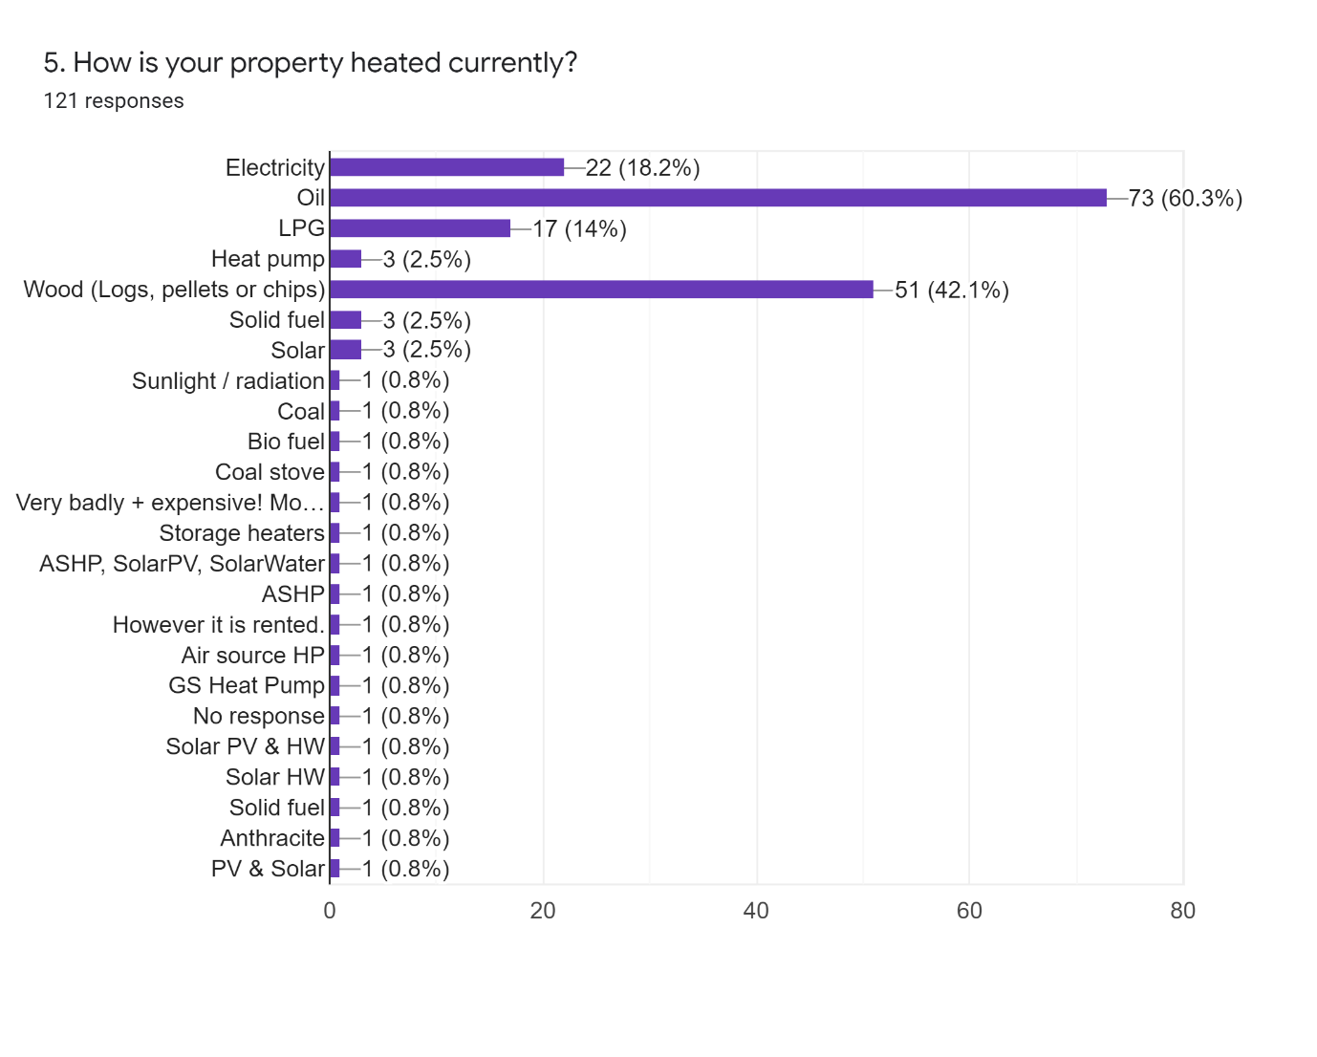
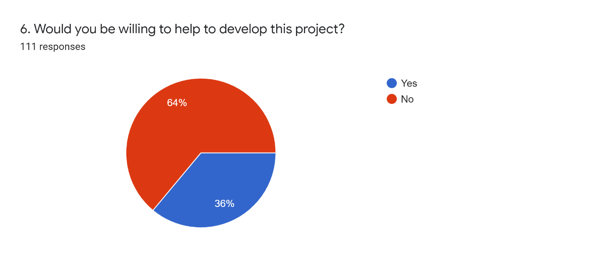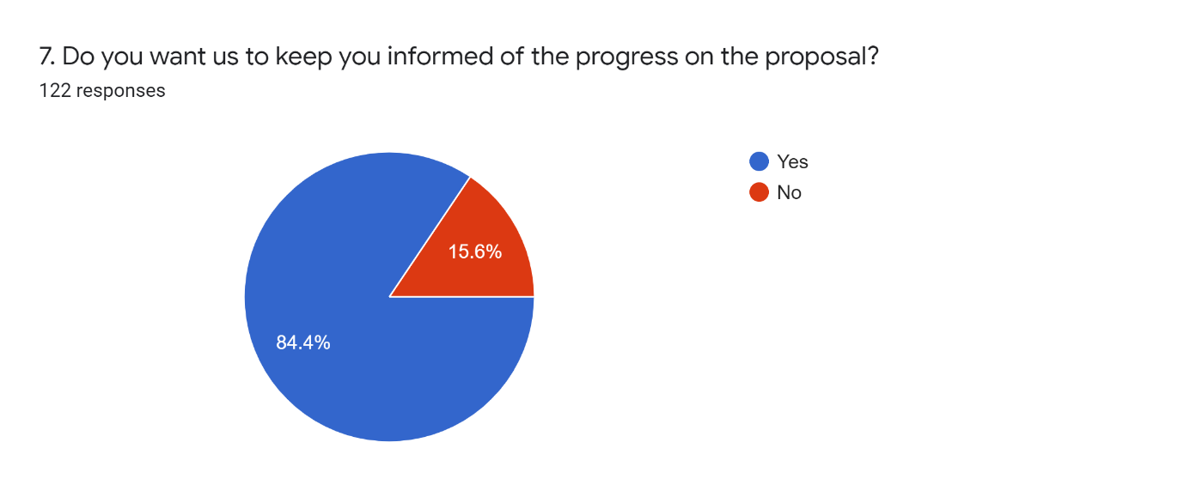
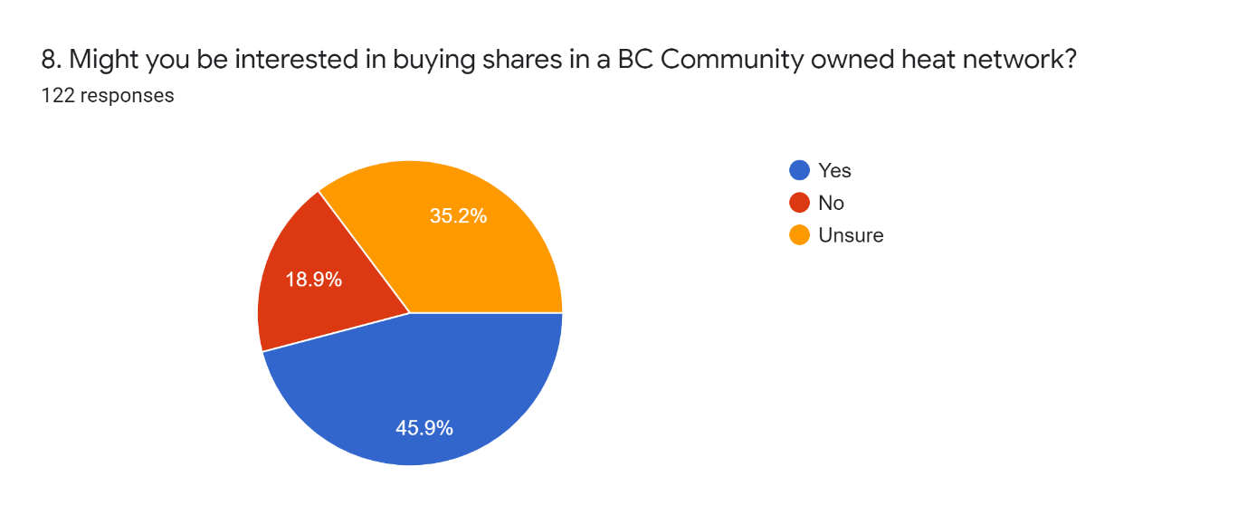
Comments Provided

Positive Comments (8)
This is a brilliant idea and has my wholehearted support!
In the light of climate change already affecting us, this is an excellent project, and could be an example to other towns and communities to do likewise
This is a fantastic idea in principle. I live in social housing and my only form of heating are electric storage heaters which are v.expensive to run and make my electricity bill £150 a month!!! Would the local Housing Association (Connexus) be on board with this scheme? It would prove a big saver for lower paid tenants of social housing
This is a great idea!
Wouldn't it be wonderful if the housing association SSHA got on board to supply their so many poorly heated houses esp. in Oak Meadow
Go for it!! Good luck this time around!!
Happy to help publicise and cheerlead from the sidelines, but lacking both time and knowledge to get more involved. Well done though, team, clap, clap
Good luck!

Neutral Comments (29)
For my personal use would depend on cost.
Our property is 3/4 mile from BC Centre. Would heat network run to this area?
Responses above conditional on better understanding - e.g. relative pro./cons. of turbine site choice. (er... if both, project could deliver more ...... m'be 'phase 2)
The turbine must not be visually intrusive to view of BC or from within the town. Site B looks like the better option from this perspective
Where is the initial funding coming from to set this up?
What is the back-up electricity proposal for the heat pumps?
We need much more detail to commit to this
We've had wet system radiators removed & electric storage heaters fitted. Help would depend on what's involved
Not sure what kind of help you require?
We have an ASHP Sorry we were unable to attend meeting
Not clear were turbines would be?,why not high up ie the Moat
I'd like to be sure there is no extra noise audible from Town from either turbine or GSHP
How many homes would one turbine supply?
We are not sure how applicable this scheme will be to us. We already have PV & Solar panels. We live on The Wintles. Our wood burner has a back-boiler that connects to a heat store
Not sure where WSW Conery is…
I'm the parish clerk in Edgton Village (Bishop's Castle ward) so not directly impacted by this initiative BUT would be interested in a conversation about Green Energy supplies in small villages like ours. ALSO this initiative if successful should be shared across the Parish Clerks network ?
What sort of help do you need? I have a spade!
Address is in one street, but access for heating pipes would need to be through our garden which is in a different street. Adds to the complexity of getting enough people in your street to make it viable What about planning permission for the heating plant and heat store? I assume this would need to be of significant size and would need planning permission? Doesn't this need to feature in the forthcoming neighborhood plan too?
The leaflet makes no mention of using the electricity to heat tanks of treated water to deliver heat to homes via heat exchangers. This was the most comprehensible, well received, and appropriate option for BC housing stock at the 3 Tuns meeting, so why no mention in this leaflet?
Site B: further from any possible future town development
Site A: less visible.
I need more information to be sure of answers to questions 3, 6 & 8. I will attend meeting on 16th
Does this extend to Brockton?
Q4: Unsure as we live in Brockton
Has there been a survey of how BC's houses are heated? My suspicion is there are a lot(?) of no-central heating/electric radiators, which can be prohibitively expensive to run - so is there grant money for the households which could benefit most from this (who weren't at the meeting, I am pretty sure?)
We're not sure what this would entail. We can't make the meeting but our question would have been the expected time-span for completion - in our lifetime?
Will residents benefit financially from the scheme (e.g. saving on electricity costs)
I am already a shareholder in the BC CLT. Can you connect?
I can't decipher where those sites are. I like the idea of it but I couldn't come to the talk as I was working
Site B. Because it is on higher ground
Site of any turbine.

Negative Comments (7)
Is this proposal a joke? Will the scheme be called the 'White elephant' and be part of the current incomer fad of Marching Elephants?
The Conery is a wholly more preferable site for the Wind Turbine. This site has a less visual impact to the whole community as Site A sits directly in the main view of all the town and any tourists, businesses and residents of the town. This wind turbine is also visible at site A from any road incoming to Bishops Castle for a couple of miles in either direction as it sits in a natural hollow in the hills. There is also going to be noise pollution from this turbine that will resonate around a peaceful town and natural surrounding areas providing a legacy to the children and residents of this town for ad infinitum. This town will be christened Bishops Windmill if this proposal goes ahead as the heritage will be lost.
I wholly object to this eyesore in site A. As a local mum and resident, I uprooted my family to move to an area of natural beauty to escape such crude and landscape damaging developments. I came to the country, as I am sure many others have as well, to be in a peaceful and natural environment with the natural sounds of the countryside. This proposal will destroy all of that and more and may even encourage residents and businesses to move. In addition, one of the key income drivers for our community is the tourist trade and local walkers and this site will deter many, spoiling the visual look and natural sounds. This eyesore will be seen from miles by many and it makes me question how much consideration has gone into identifying other more effective and less impactful options.
There is no proof that these turbines work efficiently - most of the time they rely on the normal electricity to boost them and it is apparent when travelling around the country half of them are not working. Not only are they an eyesore and would be in our beautiful part of Shropshire, why spoil it with these NOISY and RIDICULOUS looking monstrosities. There is NO PROOF that they do the work they are supposed to do - it is the "wooly-headed" folks who think they will benefit financially on having them on their land. But do they do the work as they should? I and my family ARE AGAINST all this. Why not take them and erect them in the cities and towns where carbon emissions are sky high with vehicles etc. ? The very thought of looking out of my window and having to view a turbine?.........nice words escape me!
This proposal is out of sync with much of what Bishops Castle offers. It would irreparably change the area, causing it to lose much of its appeal and unspoilt beauty. Our area can currently offer tourism and therefore investment and some form of employment for our young people, this sector is increasingly competitive and to lose it due to the erection of a huge unsightly turbine would be unforgivable. The proposed gains are questionable once all the infrastructure work has taken place to create and fit the structure, but they would certainly be wiped out once our young people all had to drive cars out of town to find employment.
This is ill considered. Your presentation was very poor and I was not convinced you had either costed this properly or considered the full impact of your proposals. Yes, we need to cut our carbon footprint - but I don't think this is the way to do it.
Absolutely no wind turbines in this area. Technology still developing and investment now is very premature. Disruption and implication for individuals greatly understated.

Dave Green,
Development Manager,
Sharenergy
dave@sharenergy.coop

